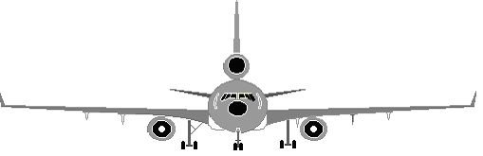
MD11 SYSTEMS

Aircraft General Hydraulic System
Air System Ice & Rain Protection
Automatic Flight System Electronic Instrument System
Communication / Navigation Landing Gear System
Electrical System FMS / TCAS / WAGS
Fire Protection APU
Flight Controls Power Plant
Fuel System

Aircraft General:
Length: 201 feet 4 inches / 61.4M
Width: 169 feet 6 inches / 51.7M
Height: min. 56 feet 9 inches / 17.3M, max. 58 feet 10 inches / 18M
The airplane wing tip has an arc of approx. 42M (134.6 feet) with normal radius turn; minimum 36M (118.5 feet) with asymmetric thrust and light differential braking.
The cockpit must have a minimum of approx. 5.5M (18 feet) of clearance from any forward object to prevent wingtip damage during the turn.
Pavement width required for a 180 degree turn is approx. 49M (160.6 feet) for a normal turn, minimum of 41.6M (134.6 feet) with asymmetric thrust and light differential braking.
The "NO SMOKE" switch when "AUTO" position is selected and the landing gear handle is selected down, the "NO SMOKING" signs illuminate.
The "SEAT BELTS" switch when "AUTO" position is selected, the "FASTEN SEAT BELTS" signs illuminate whenever the "FLAP/SLAT" handle is out of the "UP/RETRACT" position or the landing gear handle is in the "DOWN" position.
If cabin altitude exceeds 10,000 feet, the “NO SMOKING “ & "FASTEN SEAT BELTS" signs illuminate automatically regardless of switch position.

Air System:

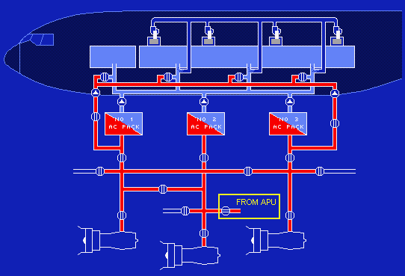
* The air system combines the operations of the pneumatic, air conditioning, and pressurization systems. These systems work in conjunction with one another to provide airflow for:

Air Conditioning and Pressurization,
Engine Starting,
Engine and Air Foil Anti-Icing,
Cargo Heating and Ventilation,
Pressurization of the Potable Water System,
Lavatory and Galley Ventilation,
Avionics Cooling,

8th stage air is low stage heated air and is the main source for normal operation.
14th stage air is high stage heated air and is used during Wing Anti-Ice operation and to compensate for low power settings, such as during idle descent.
11th stage air is used for Engine Anti-Ice protection and is routed directly to the engine cowl.

* Trim Air extracting hot air from pneumatic systems 1 and 3. This air then enters the Trim Air Manifold by way of the Trim Air Pressure Regulating Valves; from there the air is then directed to the individual trim air valves for distribution into the cabin and cockpit.
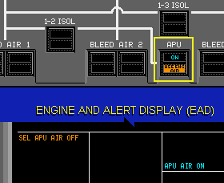

* The "Use Engine Air" light is illuminated when the air "APU" switch is selected "ON" and cabin differential pressure has exceeded a pre-set value.

* Total range for the cabin zone temp is approximately 18°C to 29°C

* 1 & 2 manifolds provide provisions for ground pneumatic air

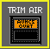
* When the "Avionics Overheat" light is illuminated; the Trim Air Manifold, which is routed through the avionics compartment, has failed.


* In ECON mode, the packs operate on low & the recirculation fans are sequenced on. When the "Off" light is illuminated, the packs operate normally and the recirculation fans are off.


* When cabin altitude is between 9,500 & 10,000 feet; pack output is increased; and the recirculation fans are commanded off.

Avionic cooling fans: Avionics equipment is cooled by avionics fans and an exhaust fan located in the avionics compartment and with CAC cooling fans located in the Center Accessory Compartment.
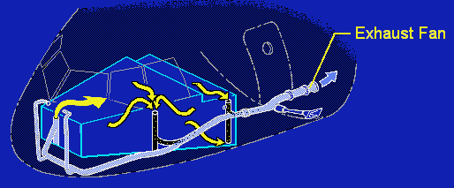
* The avionics fans supply cool air to the electronic components in the avionics and flight compartments.

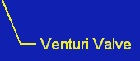
* On the ground, the Avionics Exhaust Fan is “ON” and the Venturi is “OPEN” (< 1.3 psid). Airborne, the Avionics Exhaust Fan is turned “OFF” with the Venturi “OPEN” (>1.3psid).

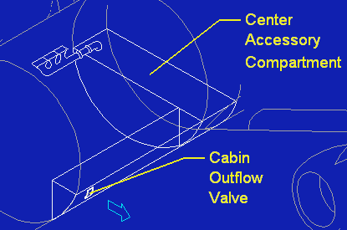

* In the Center Accessory Compartment, 3 CAC fans supply cool air to the components located in that compartment; there is no exhaust system.

* Operation of the Avionics and Center Accessory Compartment cooling fans is controlled automatically

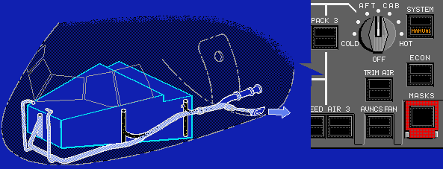


* It controls the operation of the Venturi Valve and Avionics Exhaust Fan in the manual mode.

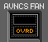
* The Venturi Valve closes as the exhaust fan is commanded on. This function reduces the discharge of cabin air overboard when airflow is too low for cabin pressurization; or stimulates the flow of avionics exhaust air when no airflow is detected.

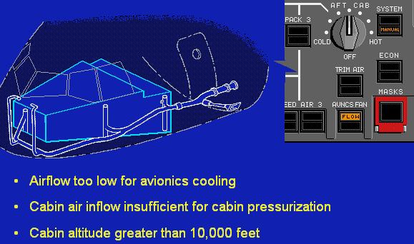

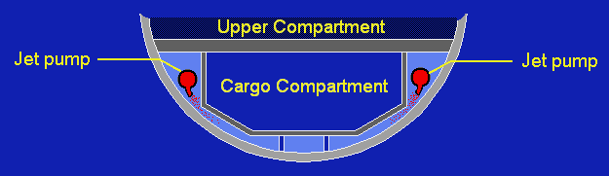
* Jet pumps supply bleed air that is used to circulate and temper the cabin air used for cargo heating.

* The FWD and AFT cargo compartments is heated, ventilated & cooled in flight by system 3 & system 2 respectively.

* The center cargo compartments is heated but not ventilated by system 2.
* The MSC automatically shuts off the ventilation system if fire is detected.
* When the T/O is made with the air system in automatic, pneumatics, air conditioning and pressurization will be restored automatically at the initial power reduction or at 4500 feet AGL, regardless of whether the T/O was made with the bleeds and/or packs off.

Pressurization System: Max Cabin differential pressure is 9.1 psi; pressure relief valve opens up at 8.9 psi. T/O & L/D is 0.5 psi.
* Max cabin climb rate is 750 fpm & max cabin descent rate is 350fpm.
* Cabin altitude will remain at departure field elevation until the aircraft altitude exceeds 5,000’ above departure field elevation.
* Pre-pressurize to 100’ below T/O field elevation when slates are extended.
* 3 Air Conditioning Controllers schedule cabin to be at 8.6 psi or less. The cabin limit altitude is 8,000 feet.
* With “PACKS OFF” departure in auto mode; the packs comes back either climb thrust is set or >4’500’.
* Oxygen masks will automatically deploy at approx. cabin altitude of 14,770’.
* Cabin rate exceeds & turns amber when: Cabin pressure >3000’ or <1500’ per minutes for 5 seconds
Cabin pressure >1500’ or <750’ per minutes for 15 seconds

Auto Flight System:
- The auto flight system (AFS) receives inputs from:
- Airframe sensors,
- Air Data Computers (ADC),
- Engine controls,
- Flight Control Panel (FCP),
- Flight Management System computers (FMS)

* These signals are processed and sent to the Electronic Information System Displays, and actuators that control pitch, roll, yaw and engine thrust.

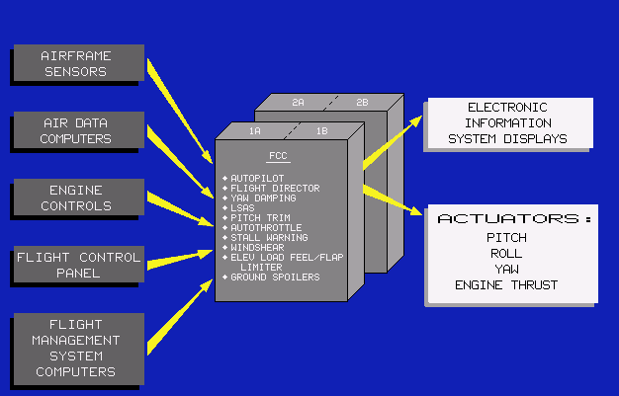

* The bank angle limits are not applicable in the T/O, G/A or localizer modes or when the FMS "NAV" switch has been pushed when computed limits apply on the PFD; the selected limits are displayed by bank angle limit marks below the arc at the top of the attitude indicator. In "AUTO", the bank angles are automatically limited to provide buffet margin protection.

* To achieve increment changes of less than 100’ feet; for example when setting an MDA, first select "BARO" on the ECP and then select the desired minimum descent altitude value using the "minimums" control knob. Next, pre-select the same "BARO" altitude in the readout with the altitude select knob; the bow-tie bug displays the desired MDA (Minimum Descent Altitude). Capture of this MDA is then assured in automatic flight.

* The G/A button, when the button is pushed the G/A mode will engage, provided the aircraft is below 2500 feet AGL with the slats extended or flaps extended 3 degrees or more; the autopilot will control speed to the G/A reference speed with pitch, and roll the wings level; the auto throttle will apply G/A thrust; in addition, the FMA will display reference speed and pitch in the speed control window, heading or track in the roll control window.

* The auto throttle system will automatically engage to provide over speed or under speed protection when a "V-Min" or "V-Max" speed limit is exceeded. During this condition, the "ATS OFF" warning will flash in white; the warning will stop when the condition no longer exists.

* When the aircraft is in level flight and the auto throttles are controlling the speed with thrust, "THRUST" is displayed in the control window; this is referred to as "Speed-On-Thrust" mode.
* When the aircraft is in a climb or descent and the autopilot is controlling the speed with pitch "PITCH" is displayed in the speed control window; this is the "Speed-On-Pitch" mode.

Defined Waypoints:
Up to 40 defined waypoints may be added to the FMC database for use on a particular flight. These waypoints are commonly created on the flight plan page. They are called Place, Bearing, Distance (PBD), or along Track offset waypoints (PD). In addition, the FMC will automatically create defined waypoints.

* A maximum of 4 individual NAVAID pages may be available for display on the MCDU. Page 1 displays the NAVID auto-tuned for EIS display. Pages 2 and 3, selected by pushing the line select key adjacent to the "next" prompt display the NAVAID auto-tuned for FMC position computation. Page 4 displays a tuned ILS DME for EIS display when within 25 miles of the facility. The NAVAID page is also used to inhibit FMS auto-tuning of a NAVAID.
* The Standby Flight Plan is displayed with current route information including the True course and distance between waypoints. New waypoints must be entered using the waypoint name, latitude and longitude, or latitude and longitude only, since the database is not available.

Communication:

* When power is applied to the aircraft, the radios receive power and automatically conduct a self-test. If the self-test fails, the word "FAIL" is displayed in both windows.

* SELCAL chime is inhibited during T/O and L/D.

* When the “ERASE” button is pushed and held for approximately 2 seconds, and the airplane is on the ground with the parking brake set, the recorder tape is erased.

TCAS:
The transponder responds to Air Traffic Control Radar Beacon System (ATCRBS) mode A, C and S interrogations. The system consists of 2 mode S transponders located in the main radio rack and 4 antennas, 2 on the top and 2 on the bottom fuselage.

* ATC/IDENT switch when pushed, a supplementary pulse is transmitted for approximately 20 seconds for augmented identification; simultaneously, in the display window, "R" is displayed next to the code identification.

* In the "STANDBY" position, power is applied to both ATC mode "S" transponders and the control panel but responses to interrogation are inhibited.

WX Radar:
The turbulence mode is limited to the first 40 Nautical Miles and turbulence is displayed in magenta. When a higher range is selected; only weather will be displayed.

* When rotated, the antenna tilt position is controllable from 15 degrees down to 15 degrees up.

IRS:
The Inertial Reference System (IRS) calculates basic navigation:
Present position, Velocity, Heading & attitude data which is input to the primary aircraft systems.

* The Inertial Reference Units (IRU) is located in the avionics compartment.

* The "NAV OFF" lights flash to indicate an alignment failure.

* The alignment mode will continue for approximately 9 minutes after the "IRS" mode selectors are rotated to "NAV". During this time the IRS will conduct a comparison test to verify the input present position is within a predetermined distance from the stored and the calculated present position. The "NAV OFF" lights will flash any time the IRS detects aircraft movement while in the alignment mode. However, normal cargo loading should not interfere with IRU alignment.

* IRU 1 Attitude, Heading and Vertical Speed data is displayed on the left PFD; IRU 2 data is displayed on the right PFD.

* If IRU1 fails, FMC1 uses IRU3 and FMC2 uses IRU2,
* If IRU2 fails, FMC1 uses IRU1 and FMC2 uses IRU3,
* If IRU3 fails, FMC1 uses IRU1 and FMC2 uses IRU2,

ACARS:
The purpose of the Aircraft Communications Addressing and Reporting System (ACARS) is to provide 2-way voice and digital data link between air and ground. It is used in conjunction with existing radio equipment to enhance the effectiveness of air-ground operational control communications.

* The ACARS system consists of: the Management Unit (MU), VHF radios and the MCDU. It collects and formats data from various sub-systems for transmission to the operator's ground-based computer system through the VHF 3 radio link.

OOOI:
The “OUT” time is automatically entered when the aircraft departs the gate (all doors closed, all engines operating and parking brake released). The “IN” time is automatically entered when the aircraft enters the gate (parking brake set for the last time, or all engines shut down and any door open).

Power Plant:

* The aircraft is powered by 3 GE CF6-80C2 series engines. Each engine is capable of delivering approximately 61,500 pounds of thrust.

* Thrust Control Module (TCM), located on the FWD pedestal
* Engine Vibration Monitoring system (EVM)
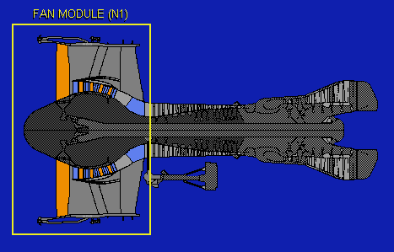

* The high bypass turbo fan engine is designed into 5 modules. First is the Low Pressure Compressor (LPC) or Fan Module, and it is referred to as the N1

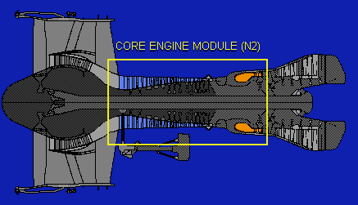

* The High Pressure Compressor (HPC) or Core Engine Module, and are referred to as the N2.

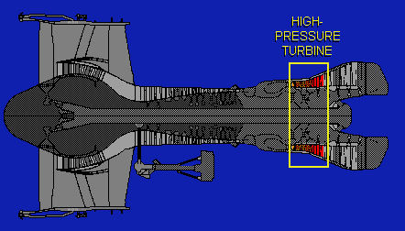

* The High Pressure Turbine Module drives the Core Engine Module

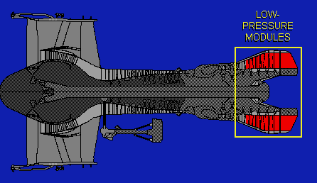

* The Low Pressure Turbine Module drives the Fan Module

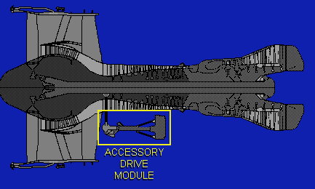
* The Accessory Drive Module extracts energy from the Core Engine Module to drive the accessories:

Starter
Electrical N2 sensor
Fuel pump
Lube & scavenge pump
IDG
Hydraulic pump
Alternator (powers the FADEC computer)

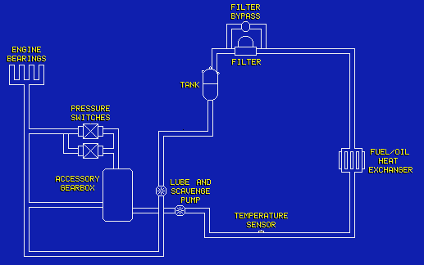

* The engine oil system is self-contained and is used to lubricate the engine bearings and accessory gear box components. In addition, a fuel/oil heat exchanger is installed to control the temperature of the engine oil. The engine oil system is a self-contained, non-regulated system. The system incorporates: a tank, pressure switches, temperature sensor, a fuel/oil heat exchanger and filter.

* Full Authority Digital Electronic Control" (FADEC)

* The FADAC system controls engine start acceleration and minimum engine idle speeds for flight and during approach. It controls thrust as a function of throttle position and provides acceleration and deceleration limiting and protection from exceeding N1, N2 and maximum thrust limits.

* The "Select" and "Alternate" lights illuminate to indicate the FADEC has lost primary input data.

* When the FADEC loses 1 channel of its Permanent Magnet Alternator (PMA), the engine operates normally; however, the "Engine FADEC Fault" alert is displayed on the systems display. When the FADEC loses both channels of its PMA, the power source switches to the aircraft electrical power and the engine continues to operate normally. The "Engine FADEC Fault" alert remains displayed on the systems display.

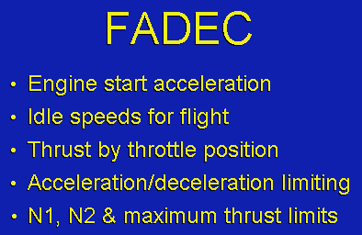
* The "FADEC backup power" alert is also displayed on the systems display, and a flashing "Engine" reminder message is displayed on the EAD

* The fan module (N1) and the low pressure compressor produce 80% of the engine thrust

* The "T" symbol indicates the throttle position and moves along the scale. The "V" indicates the FMS computed N1. When the "T" fits within the "V", the throttles are set to the computed N1.

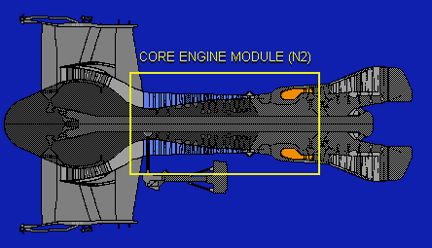

* The core engine module contains the high pressure compressor and the combustion assembly. The high pressure compressor RPM is displayed as N2 on the EAD

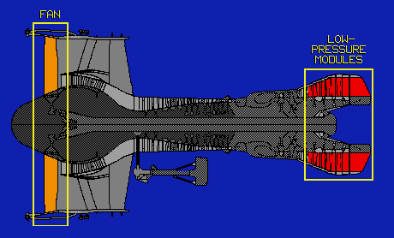
* During the start cycle, a cyan "fuel on" line is displayed across the scale to indicate the N2 at which fuel should be turned on.

* The high pressure turbine changes the combustion gases into mechanical energy to drive the N2 rotor, high pressure compressor and the accessory drive module. The low pressure turbine uses the exhaust gases to drive the fan and the low pressure compressor (N1). The core engine exhaust gases comprise 20 percent of engine thrust.

Reverser levers:
The reverser levers can only be operated when the throttles are in idle and the main L/D gear is on the ground. Throttle interlock prevents full movement of the reverser levers on engines 1 and 3 until the reversers are safely deployed.

* #2 engines have no throttle interlock. Reverse thrust is electronically limited to idle until nose gear touchdown.

* When the "G/A" switch is pushed, the auto throttles are commanded to advance to the maximum G/A thrust limits.

* Pulling an "engine start" switch causes the "start" red line limit and the "fuel on" line to appear on the EAD;
This action also commands the start valve open, initiating the engine start. The light in the start switch illuminates when the start valve opens. When the engine reaches approximately 45% N2 the start valve closes extinguishing the light; and the start switch pop back in.

* The 2 "engine fail" lights located on the pilots glare shield are active during T/O roll between 80 knots and V1. These lights illuminate when any engine N1 differs by 11% or more from the other engines.

Ignition:
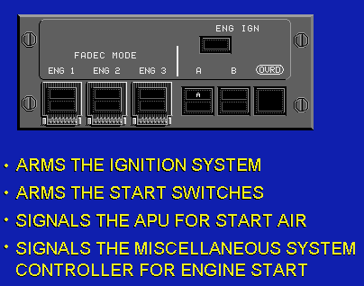
* Either A or B selected, continuous ignition is provided during T/O, L/D & engine anti-ice on (60 seconds only). The igniters automatically shut off when flaps/slats are retracted.

* This selection arms the ignition system and start switches, signals the APU for start air, and signals the Miscellaneous System Controller for engine start

* When ENG IGN OVRD is selected; both A & B igniters are powered as long as is selected.

* When the indication reaches the "fuel on" line, or a minimum of 15%, pull the "fuel" switch out and up to the "on" position.

* Normal fuel flow for engine start is from 225 to 325 kilograms per hour. The EGT indications are a normal rise within approximately 25 seconds. As N2 accelerates to approximately 45%, the start switch pops in and the light extinguishes, indicating the start valve has closed.

* Observe oil quantity decreased approximately 6 quarts at ground idle

* When all 3 engines are running, push the air "APU" switch to close the APU load control valve and begin the APU shutdown cycle.

T/O:
* At 80 knots, the display returns to "T/O CLAMP", indicating the flight crew can assume control of the throttles without interference from the auto throttle system. In addition, the engine failure warning system is activated and remains active until passing V1.

* The thrust obtained at any given N1 speed will vary with pressure, TAT, MACH number and engine bleed configuration. The FADEC will automatically monitor aircraft and engine parameters to schedule adjustments and maintain proper engine operation.

* There are 2 idle modes controlled by the FADEC. During descent, the "Minimum Idle" mode is used to minimize thrust and fuel burn. The "Approach Idle" mode provides an increased idle RPM which permits more rapid engine response to throttle movement. "Approach idle" is achieved by selecting engine anti-ice, or by extending slats or flaps.

L/D:
* During L/D, engine reversers can only be deployed after the main gear wheels are on the runway and the throttles are at idle. When the thrust reversers are deployed, the position indications are shown on each N1 display. The interlock position is displayed as "U/L" when the reversers are transitioning from stowed to deploy. When the reversers are fully deployed, the throttle interlocks on engines 1 and 3 are removed and "U/L" is replaced with "REV". Engine 1 and 3 reverse thrust may not be commanded above idle power until the throttle interlocks are removed. When #2 engine is in reverse, thrust is electronically limited to "reverse idle" until nose wheel touchdown.
* When a reverser deploys without being commanded from the cockpit "U/L" is displayed and the FADEC commands the engine to idle.

* Engine ignition system "A" for engine 1 & 3 must be operative for dispatch. (ENG IGN A on engine 1 & 3 are powered by L EM AC BUS; this arrangement provides flameout protection in the event of loss of all generators during flight.)

Engine Oil Temperature High:
* Operating with the engine oil temperature indication in the caution range is allowed for 15 minutes. Adjust the throttle to increase the fuel flow. Increasing fuel flow through the fuel/oil heat exchanger may decrease the oil temperature.

FADEC Select Alternate:
* The procedure is to disengage the auto throttles and reduce N1 RPM on the affected engine at least 20%; this will prevent an engine over-boost when the alternate mode is selected.

* During L/D, the FADEC will limit the reverse thrust to 90% N1

APU:
* The APU compartment has 3 dual-element fire detector assemblies installed.

* The APU receives fuel from the #2 tank.
* A DC electric starter motor uses A/C Battery power for APU start.
* Normally an AC powered pump is used for APU starting. A DC powered APU start pump is used when AC power is not available.

* The APU is a twin spool turbine that consists of a low pressure N1 compressor, a high pressure N2 compressor and a combustion section.

* The air system receives pressurized air from the APU N1 low pressure compressor; the RPM of N1 varies as a function of the pneumatic demands to automatically maintain the air output to the correct values for air system operation.

* The APU generator is driven by the N2 high-pressure compressor.

* The RPM of the N2 compressor is maintained at a constant speed by the Fuel Control Unit (EFCU) to provide 115 Volt, 400 Hz AC power from the generator.

* When the APU inlet and exhaust doors are fully closed, the "OFF" light extinguishes

* When the "FUEL" light is illuminated, it indicates a loss of fuel pressure to the APU. Illumination of the "FAIL" light indicates a major malfunction of the APU.
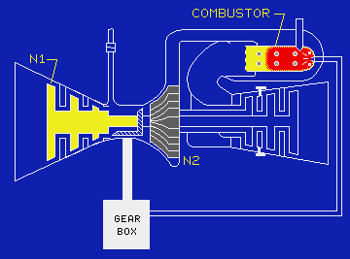

* When APU air has been in use, the APU electronic control unit allows the APU to continue running for 90 seconds prior to shutting down. When air is not in use, the APU begins an immediate shutdown

Electrical:

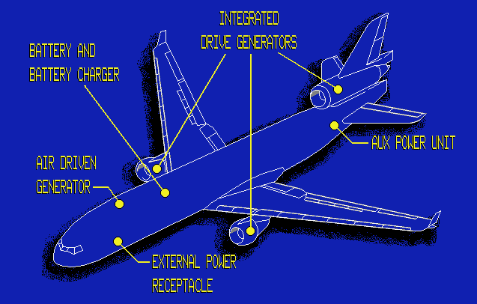

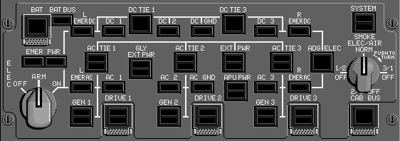

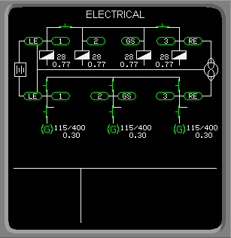
IDG:
The Integrated Drive Generators (IDG) is the primary source of AC electrical power. There is an IDG mounted on each engine. The IDG consists of a Constant Speed Drive and an AC generator in a single housing.
* Electrical load is expressed as a decimal value of total generator allowable load.

* The purpose of the Generator Relay (GR) is to connect or disconnect the generator from the Generator Bus.

* The GR is automatically controlled by the Generator Control Unit (GCU) regardless of system mode of operation.

* The "FAULT" light illuminates when IDG oil temperature and/or pressure values are not within predetermined limits.

* When main external power is supplying aircraft electrical power, an external power source must also be connected to supply galley power

* Each Generator Bus supplies power to its respective Cabin Buses. The “GALLEY BUS” switches are operative only when the electrical system is in the manual mode.

AC:
> Generator Bus 1 supplies the left Emergency AC Bus and AC Bus 1.
> Generator Bus 2 supplies the AC Ground Service Bus and AC Bus 2. The Ground Service Bus is required for in-flight operation as well as ground servicing. It is also the normal source of power for the Battery Charger.
> Generator Bus 3 supplies the Right Emergency AC Bus and AC Bus 3.
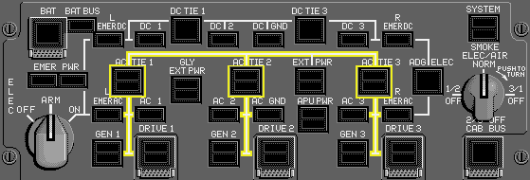
* The 3 Generator Buses are connected through the AC TIE Relays to the AC TIE BUS. This permits all generator loads to be shared equally, and allows each IDG to act as a backup for the others.

* The "AC TIE" switches operate only in the manual mode.

* In the automatic or manual mode, the AC TIE Relays open and close automatically as a function of the Generator Bus power source: Engine Driven Generator, APU generator or external power / AC TIE BUS.
* APU generator does not connect to the AC TIE BUS.

* Main external power can supply all electrical requirements except Galley power.

* When main external power is commanded on, it automatically isolates the Galley Buses from the remainder of the aircraft's electrical system. In order to power the galleys, Galley external power must be connected.
* Galley external power can only be used when DC buses 1, 2 and 3 are powered.

* The highest priority power source for the AC Tie Bus is external power. The lowest priority is the IDG.

* The highest priority power source for each Generator Bus is the associated IDG. The second priority power source for all Generator Buses is the APU generator.

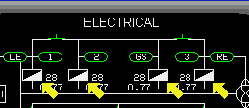
Transformer Rectifiers: * The primary sources of DC electrical power are 4 Transformer Rectifier Units (TRS). The TRS convert 115 Volt, 400 Hertz AC power into 28 Volt DC power.
* The Battery / or the ADG (through TR3) may be used as emergency DC power source.

* TR-1 receives its AC power from Generator Bus 1
* TR-2A from Generator Bus 2
* TR-2B from the AC Ground Service Bus
* TR-3 from the Right Emergency AC Bus.

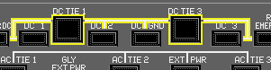
* The DC Tie Bus permits the total DC load to be equally shared by 4 TRS. In addition, this arrangement allows each TR to act as a backup for the others

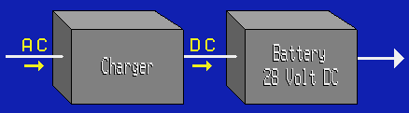
Battery & Battery Charger: A Battery charger which converts 115 Volt AC power into DC power to keep the Battery fully charged.
* Main Battery: 2 x 14 Volts = 28 volts
* Battery = 15 min, ADG (HYD mode) = 90min, ADG (ELE mode) = unlimited


* The Battery is used as a power source for the Battery Direct Bus and a backup power source for the Battery Bus. These buses power the fire detection and extinguishing circuits, the engine starting systems, and the Master Warning and Caution Systems.
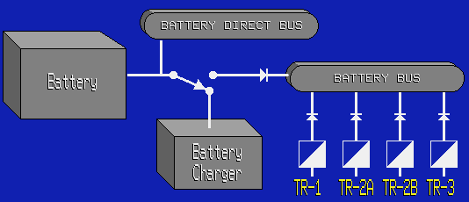
* The Battery is maintained at maximum capacity by the Battery charger; the Battery charger switches the Battery away from the Battery Bus; the Battery Bus will remain powered because it is normally powered by the DC system. The Battery is only a backup power source for the Battery Bus.

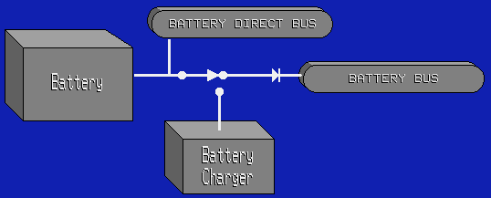

* When the parallel DC system is not supplying power, the Battery automatically disconnects from the Battery Charger and connects to the Battery Bus maintaining power on those circuits.

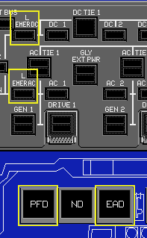

* Power priority for Emergency Lighting System:
R Emergency AC BUS
L Emergency DC BUS
Emergency Lighting Battery

* "BUS OFF" alert is displayed when any Emergency Bus is un-powered.

* The Left Emergency AC and DC Buses supply: the Captain's PFD, EAD and VHF communications radios

* Emergency Power System: Battery, Battery Charger, ADG & Static Inverter.

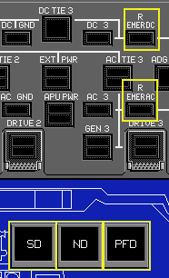
* The Right Emergency AC and DC buses supply: the First Officer's PFD, ND, and Communications Radios

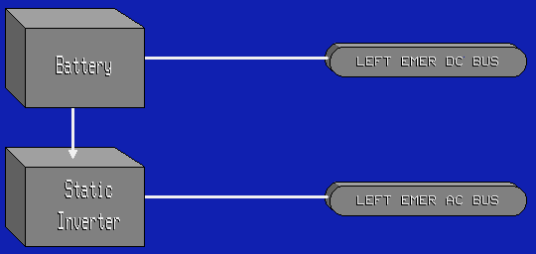

Static Inverter: An emergency power source for the Left Emergency AC Bus is a battery-powered Static Inverter.

* An emergency power source for the Left Emergency DC Bus is the Battery.

* When power is lost to Generator Bus 1; the Battery will automatically supply the Static Inverter; the Static Inverter then provides AC power for the Left Emergency AC Bus. Simultaneously, the Battery also connects to the Left Emergency DC Bus, to keep those circuits operating. The Battery and Static Inverter are controlled by a selector on the electrical control panel.
* A fully charged Battery can supply the inverter and Left Emergency DC Bus for approximately 15 minutes

* What condition causes the ELEC ALERTS message to be displayed?
A) Any GCR opens due to a fault.
* B) A loss of data signals from the EPCU. (Electrical Power Control Unit)
C) #1 DEU fails.

* What is the source of emergency AC power? ADG or Static Inverter.
* When a Generator Bus 1 fault occurs, the emergency power "ON" light illuminates to indicate the Battery and Static Inverter are supplying power to the Left Emergency AC Bus. The Battery is also supplying power to the Left Emergency DC Bus.

Air Driven Generator:
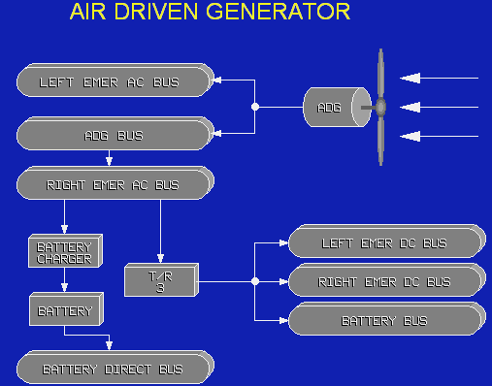
* When deployed, it will automatically provide electrical power for an electrically driven hydraulic pump and the Left Emergency AC Bus; Or, when required, power to the emergency electrical buses.

* There are no speed, altitude or attitude restrictions on the use of the ADG. The ADG cannot be retracted in flight.

* The ADG delivers regulated AC power directly to AUX HYD pump 1. The pump will pressurize HYD SYS 3, providing a backup pressure source for the aircraft's number 3 hydraulic systems. The ADG is also powering the Left Emergency AC Bus
* When normal electrical power to the Left Emergency Buses fails; the Static Inverter will power the Left Emergency AC Bus. When the ADG is deployed it will automatically connect to the Left Emergency AC Bus. The Battery will automatically connect to the Left Emergency DC Bus. Both Left Emergency AC Power and the electrically driven hydraulic pump are being supplied from the ADG.

* During emergency operation the PIC & F/O’s flight essential equipments are powered by ADG & Battery.

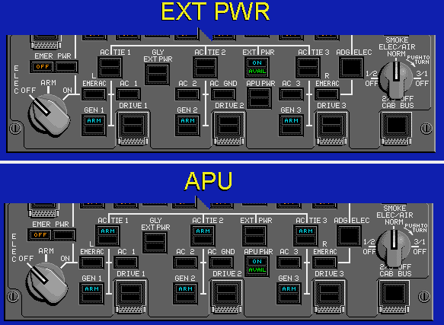
* When external power is supplying the generator buses, the AC TIE relays are closed. Observe the “AC TIE” switch "ARM" lights are extinguished.

* When APU power is supplying the generator buses, the AC TIE relays are open. Observe the “AC TIE” switch "ARM" lights are illuminated.

* If the “CABIN BUS OFF" light is illuminated, the AC Cabin Buses, Ground Service Buses and Galley Buses are deactivated.

Fire Detections:
* EVA MD11 has Class “C” FWD, CTR/AFT lower cargo compartments that require detection & fire extinguishing provisions.

* The purpose of the fire protection system is to detect overheat conditions and extinguish fires in the engine nacelles and the Auxiliary Power Unit (APU).The system also detects smoke or overheat conditions and extinguishes fires in the lower cargo compartments. It will also detect smoke and extinguish fires in the lavatories.

* Smoke, as well as overheat detectors, are located in the cargo compartments; the lavatories are equipped with smoke detectors only.

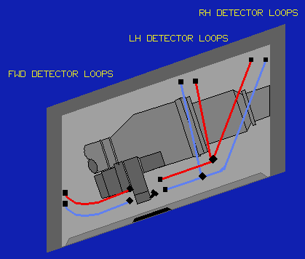

* The APU compartment also contains a dual loop detection system. Each loop consists of detectors mounted along each sidewall and in the FWD area of the compartment the purpose of this system is to detect an APU fire or overheat condition caused by a ruptured pneumatic duct

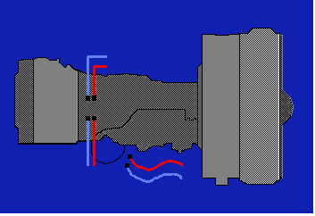

* Each engine has a dual loop detection system. Each loop consists of detectors which provide coverage for upper turbine, lower turbine and accessory core area

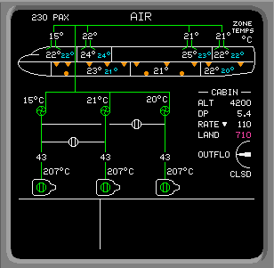

* When smoke is detected, a triangle is displayed in the corresponding area of the compartment. When heat is detected, a circle is displayed.

* Engines 1 and 3 each have two identical fire extinguishing agent (FIREX) bottles located in each wing next to the pylon.
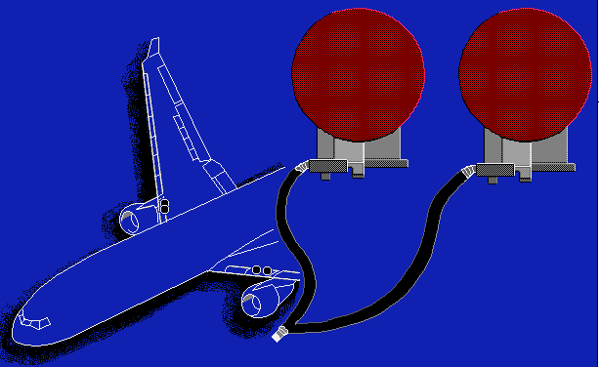
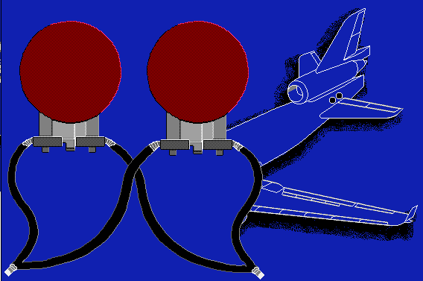

* The FIREX bottles for the #2 engine and the APU are located in the AFT fuselage. These two FIREX bottles provide fire extinguishing agents to both the #2 engine and the APU.

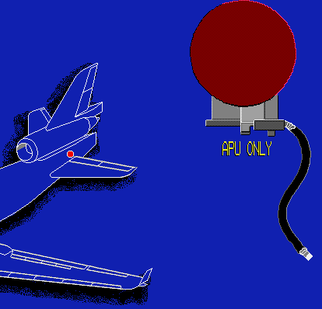

* A third FIREX bottle is provided for fire extinguishing to the APU. This bottle is automatically discharged in the event of an APU fire or overheats condition. It may also be discharged manually, when required

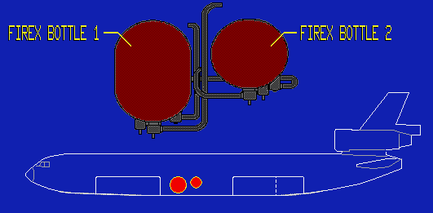

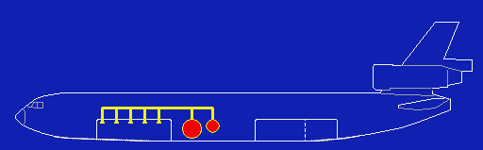
Or 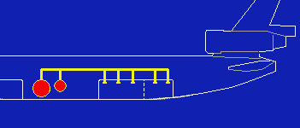
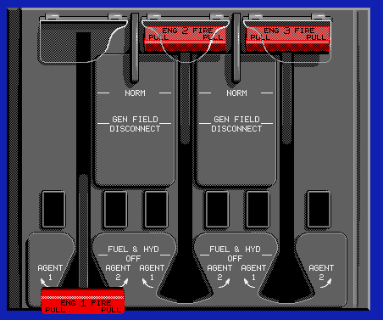
* Two Halon fire extinguishing bottles are located in CAC. Normal discharge time for bottle 1 is 28 seconds & 15 seconds for bottle 2.

* When the fire handle is pulled full down it de-energizes the generator field and shuts off the fuel and hydraulic supply for the respective engine. When the air system is in the Auto mode, the system controller will shut off the bleed air

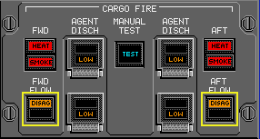

* Manual Fire test:

Flight Controls:
* The primary flight controls consist of inboard and outboard ailerons on each wing inboard and outboard elevators on each side of the horizontal stabilizer and the upper and lower rudders. The secondary flight controls include the leading edge slats the spoilers the Trailing edge flaps and the horizontal stabilizer.

Deflected Aileron:
The T/O deflected aileron system provides increased lift for T/O. The inboard ailerons are deflected 11.5 degrees and the outboard ailerons are deflected 15 degrees.

* The system is powered by an electrical actuator that works in conjunction with nose gear compression. When enabled, a signal is sent to the actuator when the "FLAP/SLAT" handle is placed in the T/O flap range. When the "FLAP/SLAT" handle is moved out of the T/O flap range and the nose gear ground shift mechanism indicates the aircraft is airborne, the ailerons retract.
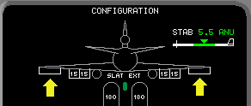

* This is the indication for normal T/O deflected ailerons

ELEVATORS:
* To improve airflow over the elevators, an aerodynamic cover and slot are incorporated. This slot greatly increases the efficiency of the elevators which have a deflection range of 35 degrees up and 25 degrees down.

* The "Elevator Feel Manual" condition is a failure of the dual channels of the elevator feel computer.

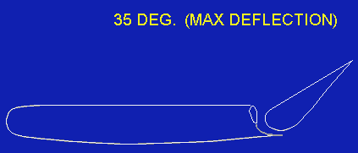
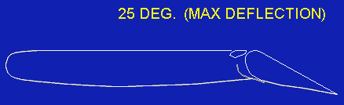

* An automatic Load Feel Control that varies elevator feel as a function of airspeed and horizontal stabilizer position is installed in the elevator system.

* Elevator load feel is computer-controlled through independent channels.

Longitudinal Stability Augmentation System (LSAS):

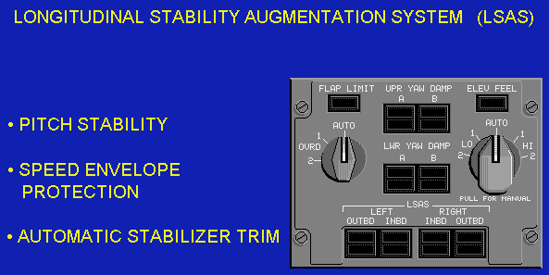

* The LSAS system is installed to increase manual longitudinal or pitch stability. It also includes speed envelope protection that introduces elevator inputs to prevent the pilot from flying below V-MIN or above V-MAX airspeeds. The LSAS controls elevator movement when the autopilot is not engaged, and automatically trims the horizontal stabilizer to off-load any sustained elevator deflections commanded by the LSAS. The control column will not move during LSAS control of the elevators. Direct manual elevator command through the control column can overpower the LSAS if the pilot so desires. Manual movement of the control column commands an aircraft pitch rate proportional to the applied force. When the applied force is removed from the control column the aircraft holds the new pitch attitude.
* “LSAS ALL FAIL” = no autopilot
Rudder:
* The yaw dampers also provide damping of Dutch Roll characteristics as well as directional stability augmentation.

Spoilers:
* The purpose of the spoilers is to provide 3 distinctive functions, lateral augmentation control, speed brakes, and ground spoilers. The spoilers consist of five panels, 1 inboard and 4 outboard, on top of each wing with individual hydraulic actuators that extend and retract the spoilers.

* When the Trailing edge flaps are extended, a lockout device prevents actuation of the “Speed Brake” handle.

* The spoiler handle is automatically deployed during a rejected T/O below 80 knots when any 2 reverse thrust levers are actuated. During a rejected T/O above 80 knots, the spoiler handle will deploy when any 2 throttles are retarded to the idle position.

* During L/D, the spoiler handle is automatically deployed to the "Ground Spoiler" position in a 2-step sequence: with the flaps in the L/D range (>Flap 31), the spoiler handle will move aft to an intermediate position and deploy partial spoilers, at main wheel spin-up; then, at nose gear touchdown, the handle will move full aft to the "ground spoiler" position.

* During L/D with flaps not in the L/D range the spoiler handle will not deploy until nose gear touchdown. At nose gear touchdown, the spoiler handle will move directly to the "ground spoiler" position without stopping at an intermediate position.
Also, when L/D on a wet or icy runway and wheel spin-up does not occur, the spoiler handle will not deploy until nose wheel touchdown; in this situation, when any 2 engine reverse thrust levers are actuated the spoiler handle will deploy directly to the "ground spoiler" position.
Upon nose gear touch down; at the same time, spoiler handle deployment will cause the automatic brakes to be applied at the previously selected rate of deceleration.

Flaps / Slats:
* When the "Flap Limit" selector is in "Auto", the flap limiting system is armed and provides automatic flap protection when flaps have been selected between 22 and 50 degrees.

* At the onset of stall warning in the clean configuration the outboard slats will automatically extend to assist in recovery from the stall; then, after recovery, the outboard slats will retract automatically. Should a malfunction occur in the automatic slat system, this alert is displayed on the EAD.
* Flaps may not extend into the L/D range when operating on Emergency Power only!
* The use of speed brakes and flaps simultaneously is a prohibited maneuver.

Abnormal cruise procedure for "Aileron Deflect Disagree": 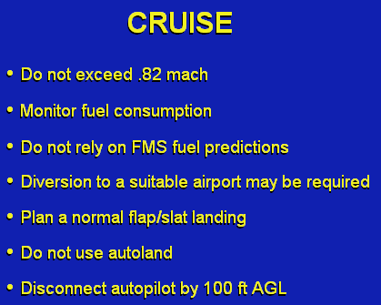
Rudder:
* When the Radio Altimeter is less than 50 feet, the Auto Trim System is inhibited.

* When the Auto Trim System becomes inoperative, LSAS disengages.

* The "Longitudinal Trim" handles override the electrical control and are mechanically connected to cables which control hydraulic motors.

* Any time the control wheel trim switches, the "Longitudinal Trim" handles or the autopilot commands the stabilizer to continuously move more than 2 degrees in flight, the stabilizer trim in motion warning sounds.

* The stabilizer trim rate is variable as a function of altitude and airspeed.

Stabilizer:
* The procedure for an inoperative stabilizer condition is to land at the nearest suitable airport.
Fuel:
* Tanks 1 and 3 have a capacity of approximately 18,460 kilograms each; tank 2 has a capacity of approximately 29,660 kilograms.

* The "Manifold" drain switch allows fuel in the manifold to drain into main tank 2, when fuel in tank 2 is less than 680 kilograms.
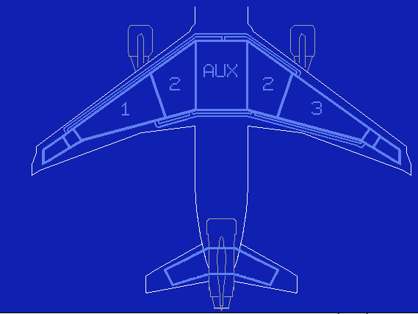
* Tanks 1 and 3, which supply fuel to the wing mounted engines, have 3 pumps each. The 3 pumps are: 1 FWD mounted boost pump, 1 aft mounted boost pump and 1 aft mounted Transfer pump.

* Tank 2, which supplies fuel to the tail mounted engine, has five fuel pumps. There are 2 AFT mounted boost pumps, 1 FWD mounted boost pump; 1 FWD mounted Transfer pump and an APU start pump.

* Cold fuel recirculation: 1 sensor each in #3 & tail tank

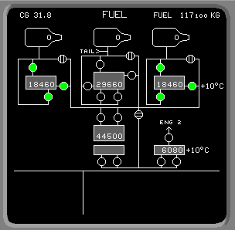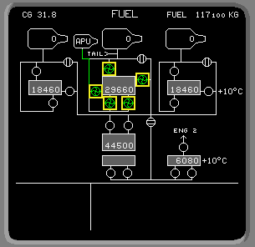

* The Transfer pumps in each tank supply fuel to a common fuel manifold routed throughout the fuel system.

* The manifold supplies fuel to the individual fuel tanks using the fill valves located adjacent to their respective fuel tanks.

* The 3 fill valves associated with the upper and lower auxiliary tanks and the tail tank operate automatically, requiring no crew action.

* When tank 2 is equal to or less than 18,144 kilograms, the "Fill" valve switch for tanks 1 and 3 must be pushed and held to transfer fuel into their respective tanks.

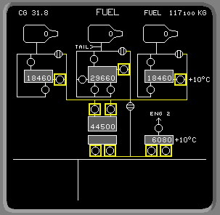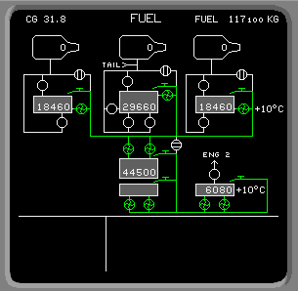

* Cross feed valves allow the fuel within the manifold to be supplied to any engine and dump valves permit fuel to be dumped overboard when required.

* The fuel quantity test may be performed in the automatic or manual mode. Push the fuel "Quantity Test" button to initiate a test of the fuel quantity indicating system. The numbers "188880" are displayed in each overhead panel readout for approximately 30 second; then the readouts go blank. 10,500 appear in each readout on the overhead panel; total fuel quantity on the synoptic indicates 52,400. After 10 seconds, the displays blank again.
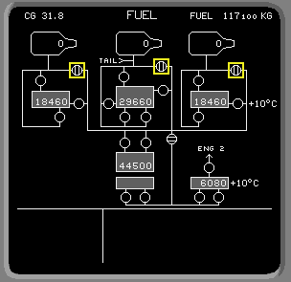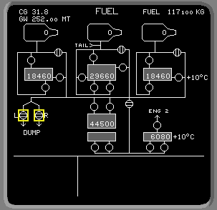

* Fuel tank ventilation is provided for by fuel vent tanks located in the wing and tail sections.
* When the "Tank Fuel Quantity Low" alert is displayed on the EAD; the fuel quantity is less than 1800 kilograms in the tank indicated.

* The dump rate is approximately 2,268 kilograms per minute. A good rule of thumb is 4 min. dump time for each 10 tones of fuel.

* When the temperature drops below a predetermined value the fuel will be re-circulated increase fuel temperature and the "Cold Fuel Recirculation" alert will be displayed. When the fuel temperature fails to increase, the "Fuel Temperature Low" alert will be displayed.

* Because of Tail Tank position is AFT of the Center Of Gravity, it is used primarily to maintain an AFT CG for efficiency.

* The purpose of the tank Transfer Pumps is to transfer fuel from its respective tank and make it available, as necessary, for cross-feeding, fuel transfer or fuel dump.

* In manual mode, the Upper Auxiliary Pumps must be commanded off by the pilot. Lower Auxiliary Pumps are commanded off automatically in either manual or auto mode when the tank is empty.
* Do not carry more than 11,340 Kg. of ballast fuel in tank 2.
* All or part of the fuel carried in Upper AUX tank may be ballast fuel.

Tail Fuel Management:
* In the automatic mode, tail fuel management is accomplished automatically by the Fuel System Controller. In the manual mode, fuel can not be transferred from the main tanks to the tail or auxiliary tanks; therefore there is no tail fuel management.

Q: What does “TAIL FUEL FWD” indicate? A: The CG automatic control system is no longer operating.

* When fuel is retained in the tail for CG demands in automatic mode, it will be transferred to the main tanks when the aircraft descends through 26,750 feet, or when the quantity of any main tank decreases to approximately 5200 kilograms. The tip tank fuel Transfer occurs when main tanks 1 and 3 reach approximately 5200 kilograms; at that time, the Transfer valve automatically opens between the main compartments of these tanks; tip fuel Transfers by gravity from the tip to the main tank, making the tip fuel available for consumption.
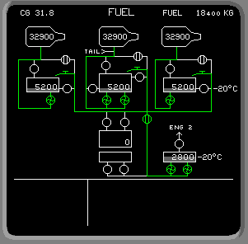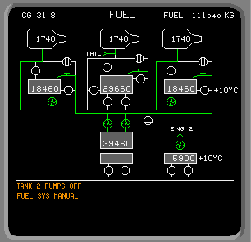
"Tail Tank Pumps Low" condition in manual mode,
Q: When you see: “TANK 2 PUMPS LO” it means that FWD and AFT pump pressure in tank 2 is low.
Q: When the associated “TANK__PUMPS LO” alert message is displayed, what is an alternate means to supply fuel to its respective engine? A: Start its respective transfer pump and open its respective cross feed valve.
Q: During descent, with a “TANK__PUMPS LO” alert displayed, what is the recommended procedure for providing an alternate fuel supply? A: Initiate cross feeding from another tank.
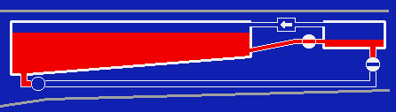
* When fuel transfers prematurely from the wings outboard compartment to its inboard compartment; the respective "Tank Tip Fuel Low" alert is displayed on the synoptic.

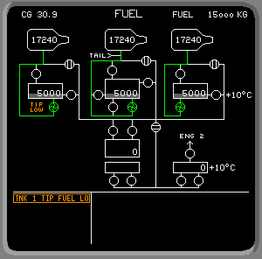

* To Transfer fuel from the inboard tank back to the outboard tank, first, push the "Transfer" switch for the affected wing tank and observe the "On" light illuminates, then push and hold the tank "Fill" switch, and observe the "Arm" and "Fill" lights illuminate. This will cause fuel in the inboard tank to be redistributed to the outboard tip tank. When the alert is no longer displayed, wait 2 minutes, and then release the associated tank "Fill" switch and observe the "Arm" and "Fill" lights extinguish; then push the associated "Transfer" switch, and observe the "On" light extinguishes.

Ballast Fuel:
Ballast fuel may be carried in tank 2, the Upper Auxiliary Tank or the Tail Tank. Tank 2 is allowed to have up to approximately 11,340 kilograms of ballast fuel in addition to usable fuel. All or part of the fuel in the Upper Auxiliary Tank may be ballast. The Tail Tank must be all ballast or all usable fuel. When ballast fuel is carried in the Tail Tank, the Tail Tank ballast left and right Transfer Pump Lockout Switches must be selected off on the maintenance panel. When ballast fuel is carried, the flight crew must enter the amount and location of the ballast in the FMS; the system controller then manages it appropriately.

Manual Reversion:
When the system reverts to manual, the fuel system controller establishes the following configuration:
The tank pumps in tanks 1, 2 and 3 are commanded on,
The left and right Auxiliary Tank Transfer pumps and the Tail Tank Transfer pumps are commanded on,
The cross feed valves, tail alternate pump, and tanks 1 and 3 Transfer pumps are commanded off,
The fill valves and tank 2 Transfer pumps remain in their previous state.

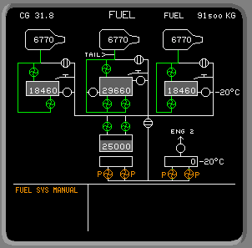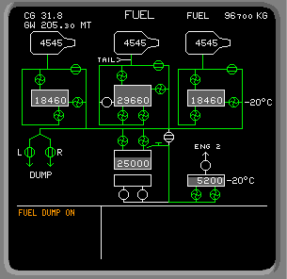

Fuel dump: the fuel dump control then commands all Transfer and boost pumps on, all cross feed valves open. Dump rate: 2,268kg/min. Impossible to dump below 15,600kg.

ICE & RAIN PROTECTION

* The wing, tail, and engine surfaces that require ice protection are heated with engine bleed air; the windshields, windows and air data sensors are heated electrically. In addition, the aircraft is equipped with dual automatic ice detection and alerting system.

* In flight, above 17,750 feet, the "No Ice Detected" alert will be displayed when an engine or airfoil anti-ice switch is selected on and no icing conditions exist.

* Only the 5 outboard (4 through 8) segments of the slats are heated. The hot air is routed to the desired areas by a duct inside the slats.

* The windshields are anti-iced and defogged, but the windows are only defogged

* The ESC inhibits an engine Anti Ice DISAG annunciation while the FUEL switch is selected OFF. The DISAG annunciation is also inhibited for up to 45 seconds after the FUEL switch is selected ON.

* The engine cowl Anti Ice uses hot engine bleed air from 11th stage.

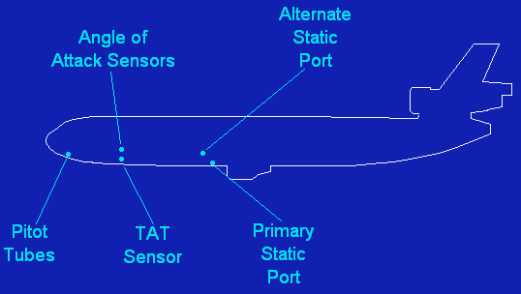
* Air Data Sensors are electrically heated. The sensors are; the Pitot Tubes, Angle of Attack Sensors, Static Ports and Total Air Temperature Sensor. Ice detect sensors are located in engine 1 and engine 3 inlet cowls.
* The Total Air Temperature Sensor is only heated in flight.
* Wing anti-icing is available with the slats extended or retracted.
* The wing anti-ice system is not operative when the aircraft is on the ground, but can be armed to function when the aircraft rotates.

* The leading edge slats & leading edge of the horizontal stabilizer may be damaged if the airfoil anti-ice system is operated on the ground longer than 30 seconds.

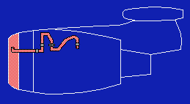

* Hot bleed air for nose cowl anti-icing is taken from each engine's compressor bleed port. The air is routed to the anti-ice shutoff valve, through an air duct and ejected into the cowl area by a nozzle

* "Engine 2 Anti-Ice Duct Failure" is displayed when a leak is detected in the engine 2 anti-ice duct manifold.

* The ESC depressurizes pneumatic system 2 after 25 seconds if the anti–ice valves disagree condition continues to exist.

* The MSC turns on all Air Data Heat (except TAT) when any engine Fuel switch is moved to ON. The MSC turns these heating systems (except TAT) off when all 3 engine Fuel switch is moved to OFF.

* The MSC allows the TAT heat to be on only when the ground sense mechanism senses flight.

* The Wing & Tail Anti-Ice system must be selected off if the Air System is in Manual Mode.

* The ice detection system is tested when the ANNUN LT TEST button is pushed until the AIR SYS TEST alert is displayed. A preflight failure of the ice detection system does not cause the AIR SYS TEST FAIL alert to be displayed.

* IGN OVRD must be selected ON for T/O whenever any ANTI-ICE is selected ON.

ELECTRONIC INSTRUMENTATION SYSTEM:

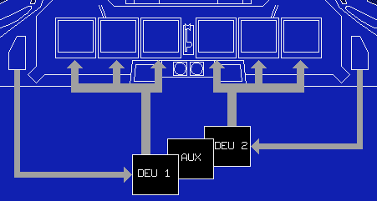
* The Source Input Select Panels (SISP) provides each pilot with the capability to select alternate flight data sources.

CADC: CADC 1 supplies the Capt’s PFD with airspeed & altitude info; CADC 2 supplies the FO’s PFD with airspeed & altitude info.

* In an emergency power condition only DU1, DU2 & DU3 are powered.
* DEU 1 drives the Captain’s DU 1, DU 2 & DU 3; DEU 2 drives the FO’s DU 4, DU 5 & DU 6; DEU 3 is AUX.

HYDRAULICS:
* The purpose of the hydraulic system is to provide hydraulic power to the flight control surfaces, landing gear, nose wheel steering and wheel brakes.

* Each hydraulic system contains a fluid reservoir which supplies hydraulic fluid to the Engine-Driven Pumps. 2 Engine-Driven Pumps, a left pump and a right pump are attached to the accessory case of each engine.

* The other major components of the hydraulic system are 2 hydraulically driven Reversible Motor Pumps located in the center gear wheel well; 2 hydraulically driven Non-Reversible Motor Pumps located in the tail section of the aircraft and 2 electrically driven Auxiliary Pumps located in the right main L/D gear wheel well.

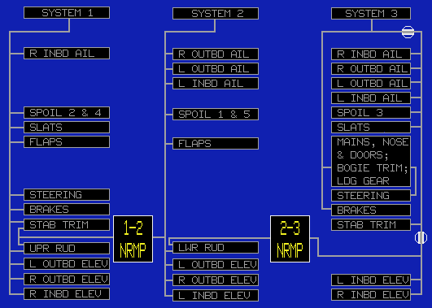

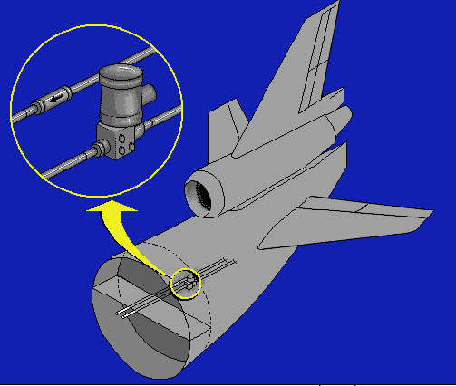

* A unique feature of the number 3 hydraulic system is the enhancement capability. It is designed to prevent a total loss of hydraulic fluid if a severe leak occurs AFT of the rear fuselage pressure bulkhead.

* The Engine-Driven Pump switches and the Reversible Motor Pump switches are only functional during manual operation.

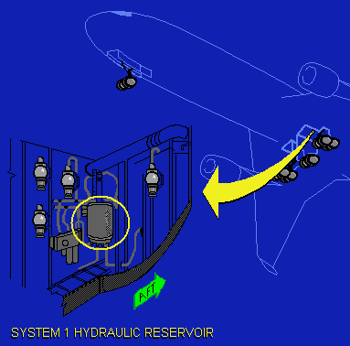
* When in automatic mode, these pumps are controlled by the Hydraulic System Controller. When any Engine-Driven Pump or Reversible Motor Pump switch is pushed during automatic operation; the "Manual" light will flash indicating the switch is not functional.

* The Auxiliary Pump switches are functional in both manual and automatic modes.

* Hydraulic system 1 reservoir is located in the left main gear wheel well

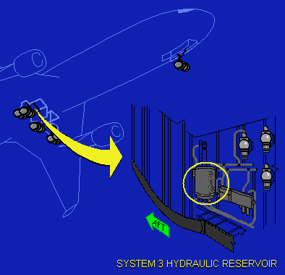

* System 3 reservoir is located in the right main gear wheel well

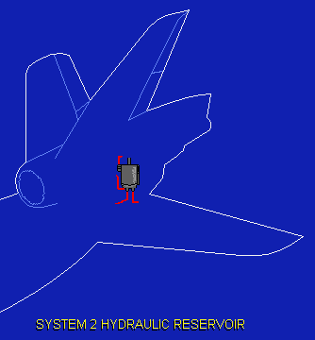

* The system 2 reservoir is located in the tail section near engine 2

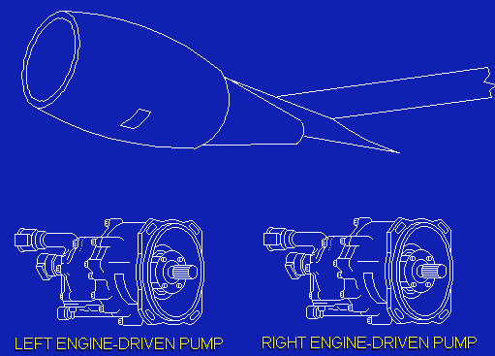

* Each system is pressurized by 2 Engine-Driven Pumps mounted on the accessory case of each engine

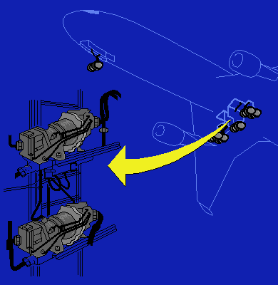

* 2 hydraulically driven Reversible Motor Pumps are located in the center landing gear wheel well. These pumps are installed between systems 1 and 3, and systems 2 and 3. Their function is to mechanically provide pressure from an operating pressure source to an un-pressurized system, through the use of an interconnected hydraulic motor and pump. There is no exchange of system fluid. It is only a mechanical means of pressurizing a system. This operation can be reversed to provide hydraulic pressure in either direction; thus the term reversible motor pump is applied.

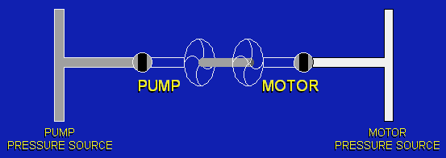

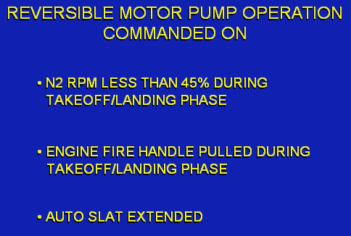
* During automatic operation, there are conditions which will cause both Reversible Motor Pumps to be commanded on. These are: any engine N2 RPM less than 45% during the T/O or L/D phase of flight; any "Engine Fire" handle pulled FWD, to, or past the "Fuel & Hydraulic Off" position during the T/O or L/D phase of flight or any time a signal is received from the Auto Slat Extend System

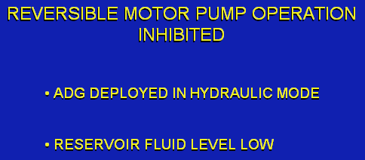

* Reversible Motor Pump operation is inhibited if: the ADG is deployed and operating in the hydraulic mode or a signal is received from the reservoir fluid low level switch

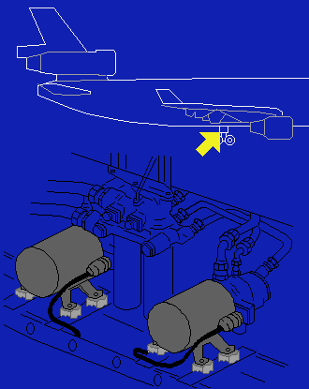
* The hydraulic system incorporates 2 electrically driven Auxiliary Pumps located in the right main L/D gear wheel well. Their main purpose is to provide hydraulic power during ground operations; however, Auxiliary Pump number 1 also serves as an emergency source of hydraulic power when powered by the Air Driven Generator (ADG)

* The number 1 Auxiliary Pump can be powered by electrical power from the Air Driven Generator.

* In addition, the number 1 Auxiliary Pump may be operated from the brake control panel.

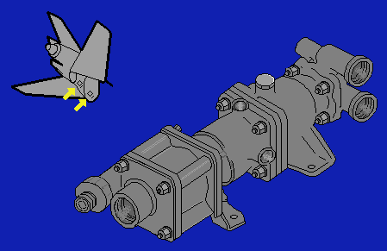
* 2 hydraulic driven Non-Reversible Motor Pumps are located in the tail section of the aircraft. These pumps are situated between systems 2 and 1, and systems 3 and 2. Unlike the Reversible Motor Pumps, these pumps transfer power in one direction only; therefore they are referred to as Non-Reversible Motor Pumps. The purpose of the Non-Reversible Motor Pumps is to provide an alternate source of hydraulic power for the rudder system and stabilizer trim.

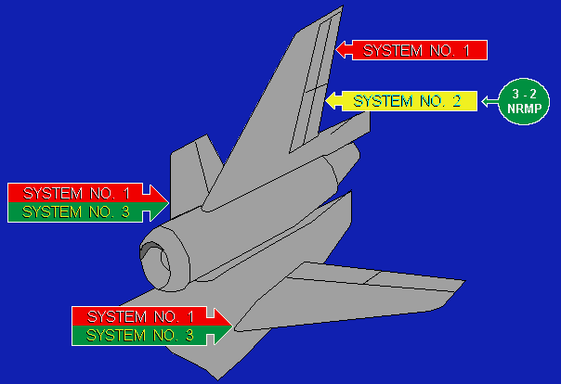

* When system 2 pressure is lost; hydraulic system 3 serves as the backup power for system 2 through the use of the 3-2 Non-Reversible Motor Pump; thus providing hydraulic power to the lower rudder.

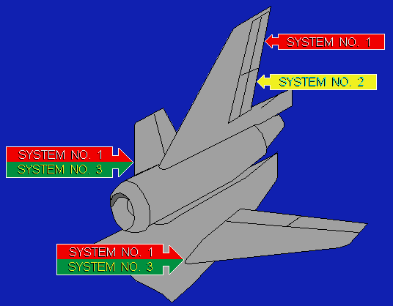

* During normal operation, the upper rudder is powered by hydraulic system 1, the lower rudder is powered by hydraulic system 2 and the stabilizer trim is powered by hydraulic systems 1 and 3
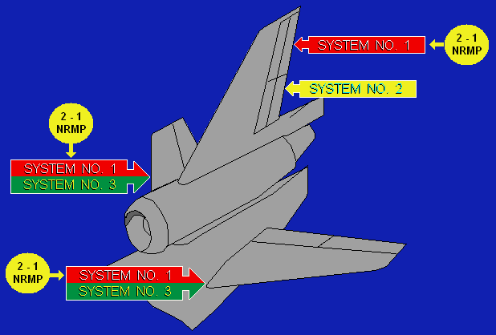

* When system 1 pressure is lost; alternate hydraulic pressure is supplied to the upper rudder and stabilizer trim from system 2 through the 2-1 Non- Reversible Motor Pump.

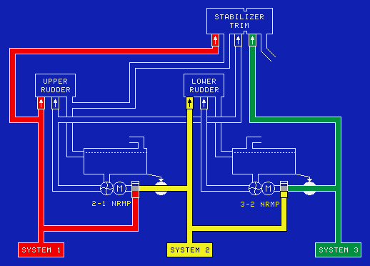

* When system 2 pressure is lost; hydraulic system 3 serves as the backup power for system 2 through the use of the 3-2 Non-Reversible Motor Pump; thus providing hydraulic power to the lower rudder.

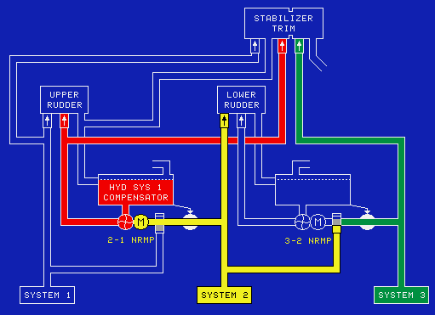

* When system 1 pressure is lost; the pressure operated shutoff valve opens allowing fluid from system 2 to motorize the 2-1 Non- Reversible Motor Pump and pressurize system 1 using the fluid stored within the system 1 compensator.

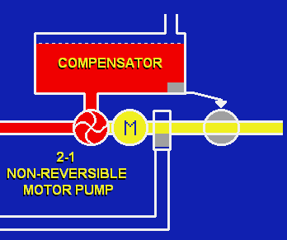

* The compensators store fluid for use by the Non-Reversible Motor Pump to compensate for a loss of fluid elsewhere in the system

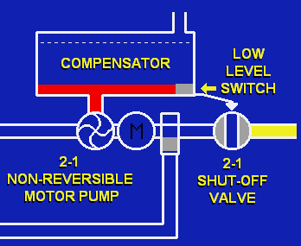

* Each compensator has a low level switch that will close the electrically operated shutoff valve when compensator fluid level reaches a preset value, rendering the Non-Reversible Motor Pump inoperative

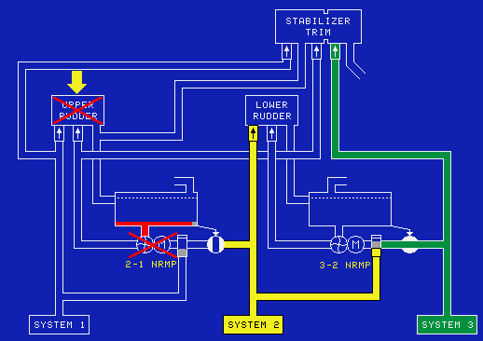

* When the 2-1 Non-Reversible Motor Pump and hydraulic system 1 are both inoperative the upper rudder is not available. However, with a loss of system 1 pressure, the stabilizer trim will continue to be pressurized by hydraulic system 3

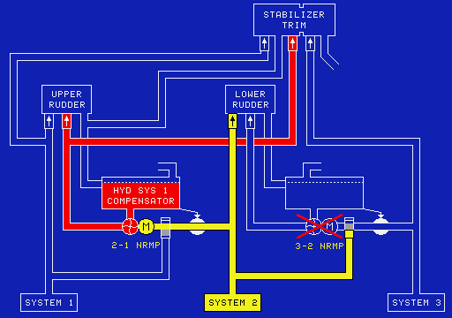

* Non-Reversible Motor Pump operation is also adversely affected by a dual hydraulic failure. For example, a loss of systems 1 and 3 would cause the 3-2 Non-Reversible Motor Pump to be inoperative; since the 2-1 Non-Reversible Motor Pump provides an alternate source of power to the upper rudder and stabilizer trim no alert regarding the rudder is displayed

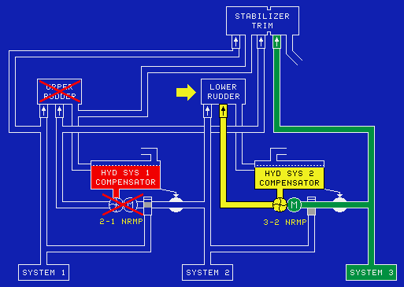

* When a failure occurs in hydraulic systems 1 and 2, the 2-1 Non-Reversible Motor Pump is inoperative; the lower rudder actuator will continue to be pressurized by the 3-2 Non-Reversible Motor Pump. However, due to the loss of primary and secondary pressure sources, the upper rudder is inoperative; therefore, the "Rudder Upper Inoperative" condition will be displayed on the EAD as a flashing "HYD" reminder message.

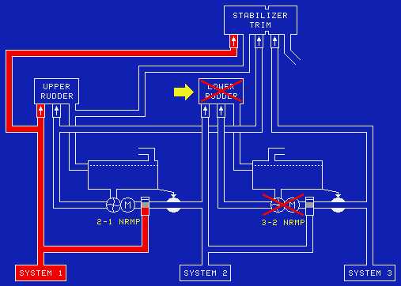
* The "Rudder Both Inoperative" alert will be displayed if the system 2 compensator fluid quantity is low.

* When a failure occurs in hydraulic systems 2 and 3, the 3-2 Non-Reversible Motor Pump is inoperative.
Stabilizer Trim will continue to be pressurized by hydraulic system 1. However, this condition would cause the lower rudder to be inoperative. Consequently, the "Rudder Lower Inoperative" alert will be displayed on the EAD as a flashing "HYD" reminder message.
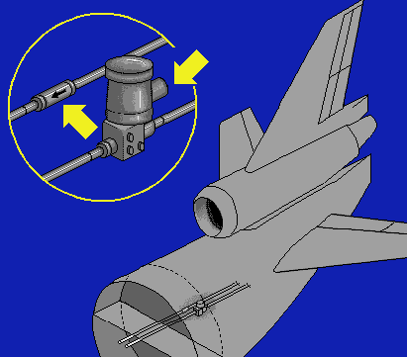

* Incorporated in the number 3 hydraulic system enhancement feature is a check valve in the return line; and a motor operated shutoff valve in the supply line. Both are located in the AFT fuselage compartment
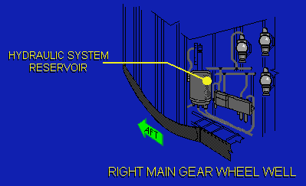

* A quantity sensor switch is located on the number 3 hydraulic system reservoir

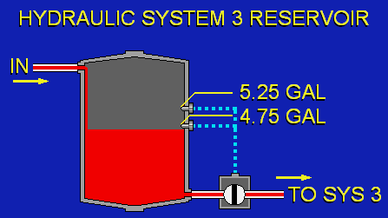
* It’ll commands the shutoff valve open when the quantity level is above 5.25 gallons. When the reservoir fluid quantity decreases below 4.75 gallons, the shutoff valve is commanded to close and the "Hydraulic 3 Elevator Off" alert is displayed on the EAD. When the valve is closed, the number 3 elevator system and the 3-2 Non-Reversible Motor Pump are disabled. If the number 1 and 2 hydraulic systems are fully operational, the primary flight controls will continue to operate normally with this valve closed.

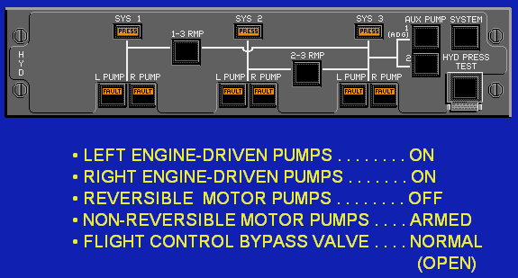
* Prior to engine start, with the system in automatic or manual mode, the normal configuration for the hydraulic system is:
The left and right engine driven pumps are commanded on, the reversible motor pumps are commanded off; the Non-Reversible Motor Pumps are armed. Finally, the flight control bypass valve must be in the normal (open) position. If the bypass valve is not in the normal position, the "HYD SYS 3 ISO" alert is displayed on the EAD.

Single Hydraulic System Failure:
* Hydraulic System 1 Failure:
Hydraulic system 1 powers the #2 autopilot.
The upper rudder will be powered by the 2-1 Non-Reversible Motor Pump.
Brake system 1 is limited to accumulator pressure only.
Verify the "Auto Brake" selector is in "OFF" position.
Flaps and slats may not extend if the aircraft is in excess of the MLDW. Plan on using 35 degrees of flaps for L/D.
After L/D, nose wheel steering will be restricted to the left, full nose wheel steering is available to the right.

* Hydraulic System 2 Failure:
Hydraulic system 2 powers the #1 autopilot.
The lower rudder will be powered by the 3-2 Non-Reversible Motor Pump.
Flaps may not extend if the aircraft is in excess of the MLDW. Plan on using 35 degrees of flaps for L/D.

* Hydraulic System 3 Failure:
Verify the "Auto Brake" selector is in "OFF" position.
Slats may not extend if the aircraft is in excess of the MLDW. Plan on using 35 degrees of flaps for L/D.
When L/D gear extension is required, use the alternate gear extension method. Observe
alternate gear extension speed of 230 knots.
After L/D, nose wheel steering will be restricted to the right; full nose wheel steering is available
to the left.

* Hydraulic System 3 Elevator Off:
This alert confirms that the motor operated shutoff valve is closed and pressure is not available to operate the 3-2 Non-Reversible Motor Pump or the system 3 elevator actuators. Brake system 2 is limited to accumulator pressure only.
When system 3 hydraulic reservoir quantity is stabilized above 4.0 gallons, the leak is isolated in the area AFT of the AFT pressure bulkhead; and the 3-2 Non-Reversible Motor Pump and system 3 elevator actuators are inoperative. All other hydraulic system 3 components FWD of the bulkhead will continue to operate normally. When the alert is displayed and hydraulic system 3 reservoir quantity is decreasing, the leak is FWD of the AFT pressure bulkhead.

When the hydraulic system is in the automatic mode, the quantity will continue to decrease to a predetermined value and then the Engine-Driven Pumps are automatically commanded off.
When the hydraulic system is in the manual mode, the system 3 Engine-Driven Pumps must be commanded off by the crew.

Dual Hydraulic System Failure:
* Hydraulic 1 & 2 Failure:
When hydraulic systems 1 and 2 have failed, the upper rudder is inoperative; as a result, VMCA is 160 knots and the recommended maximum crosswind limit is 12kts. If the flaps are extended, leave the "Flap/Slat" handle in the existing position. If flaps are retracted, plan a Slat Extended/Zero Flap landing. When ready to extend slats it may be necessary to reduce speed to enable full deployment; if slats are not fully deployed within a predetermined time, the "Slat Disagree" alert will be displayed on the EAD and the configuration synoptic.
Calculate the "0 Degrees/Extend" landing distance using the "0 Degrees/Extend" landing ground distance chart and plan a long final approach.
When landing gear extension is desired, use the alternate gear extension method. This action ensures hydraulic fluid is available to the flight controls. The main gear alternate extension lever must be stowed to enable nose wheel steering from hydraulic system 3. After L/D, nose wheel steering will be restricted to the left, but full travel will be available to the right.
When the landing flap setting is less than 35 degrees, the "Ground Proximity Warning" switch must be moved to the "Flap Override" position to prevent actuation of the GPWS "Too Low - Flaps" aural warning.
Verify the "Auto Brake" selector is in the "OFF" position.
Brake system 2 will have normal pressure from hydraulic system 3. Brake system 1 will be limited to accumulator pressure.
Both autopilots will be inoperative. The auto throttles may be used, but must be disconnected prior to 50 feet AGL. The auto throttle retard mode will not function when the flaps are not in the landing configuration.
With only 1 hydraulic system operating, (spoiler panels 3 are operative on each wing) the spoiler drive system may not have enough power to move the spoiler handle to the "Ground Spoiler" position; after touchdown, it is necessary to manually assist the handle as it deploys.

* Hydraulic 1 & 3 Failure:
If the "Rudder Upper Inoperative" alert is displayed, the 2-1 Non-Reversible Motor Pump is failed. With the upper rudder inoperative VMCA is 140 knots, and the recommended maximum crosswind limit is 12kts, and the stabilizer trim system is inoperative; the abnormal non-alert procedure, "Stabilizer Inoperative", is used for this condition.
If slats are extended, the "Flap/Slat" handle must remain in the "Slats Extend" range. Plan the landing with flaps 35 degrees extend and use normal landing speeds.
If the slats are retracted, they can not be extended. The "Slat Stow" switch is used to inhibit the slat extend command prior to moving the "Flap/Slat" handle to the "0 Degrees/Extend" position.
This will allow flap extension without slat extension. When "SLAT STOW" is selected, the recommended landing flap position is 28 degrees; refer to the "28 Degrees/Retracted Approach Speeds and Landing Distances" chart.
When landing gear extension is required, use the alternate gear extension method. When the landing flap setting is less than 35 degrees, the "Ground Proximity Warning" switch must be moved to the "FLAP OVERRIDE" position to prevent actuation of the GPWS "TOO LOW - FLAPS" aural warning.
Brake systems 1 and 2 will be limited to accumulator pressure. Auto brakes can not be used. Verify the "Auto Brake" selector is in the "Off" position.
Auto-pilot 2 will be inoperative. The auto throttles may be used, but must be disconnected prior to 50 feet AGL.
The auto throttle retard mode will not function when the flaps are not in the landing configuration.
With only 1 hydraulic system operating, (spoiler panels 1 & 5 are operative on each wing) the spoiler drive system may not have enough power to move the spoiler handle to the "Ground Spoiler" position. After touchdown, it is necessary to manually assist the handle as it deploys. Nose wheel steering is not available. Use differential braking as required for directional control.

* Hydraulic 2 & 3 Failure:
When hydraulic systems 2 and 3 are failed, the fluid qty is less than 1 gallon; the lower rudder is inoperative. As a result, VMCA is 180 knots and the recommended maximum crosswind limit is 12kts.
The recommended L/D Flap/Slat position is "28 Degrees/ Extend".
When L/D gear extension is required, use the alternate gear extension method.
Brake system 1 will have normal pressure from hydraulic system 1. Brake system 2 is limited to accumulator pressure. Auto brakes can not be used.
Autopilot 1 will be inoperative. The auto throttles may be used, but must be disconnected prior to 50 feet AGL.
The auto throttle retard mode will not function when the flaps are not in the L/D configuration.
With only 1 hydraulic system operating, (spoiler panels 2 & 4 are operative on each wing) the spoiler drive system may not have enough power to move the spoiler handle to the "Ground Spoiler" position. It is necessary to manually assist the handle as it deploys.
After L/D, nose wheel steering is restricted to the right, but full travel is available to the left.

L/D GEAR:

* Aircraft hydraulic system 3 furnishes the power to retract and extend the landing gear.
* MAX tire speed is 204 kts
* Nose gear steering: 70 degrees either side; rudder pedal steering: 10 degrees either side.
* The auto brakes are activated when the spoilers are deployed.

* The center gear is installed to reduce the force on the runway and ramp at maximum T/O gross weight.
* The center gear extends and retracts in conjunction with the main gear; it is equipped with brakes that operate simultaneously with the main gear brakes
* A "Brake Differential Temperature" alert is displayed on the EAD when adjacent brake temperatures on the same axle exceed a predetermined value, either warmer or colder.
* A "Tire Differential Pressure" alert is displayed on the EAD when an excessive differential pressure between paired tires is detected.

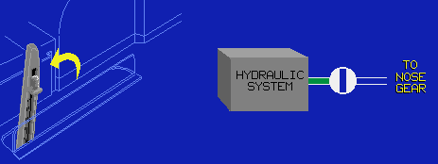
* Nose gear steering is partially affected by the use of the alternate gear extension lever. When the lever is raised, hydraulic system 3 is bypassed and nose gear steering is restricted to the right

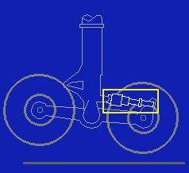
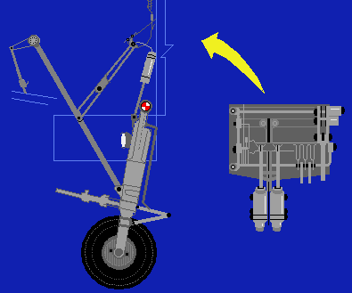
* The Air/Ground sensing mechanism is installed on the nose gear of the aircraft. The purpose of ground sensing is to signal several aircraft systems that the aircraft is either in the ground or flight mode; this is accomplished by a linkage that senses oleo strut extension which actuates the air/ground sensors.

Tire Pressure:
Main gear – 210 psi
Center gear – 176 psi
Nose gear – 180 psi

*Each main gear truck is equipped with an automatic leveling device which ensures that the truck is level prior to gear retraction. When the truck is out of level, the "gear" handle cannot be moved to the "up" position; in this case, use of the "gear handle release" button is not available.

* If the "gear" handle will not move to the "up" position, the main gear bogie trim has failed.

Brakes & Anti-Skid:
* Brakes are installed on each main gear and center gear wheel. Each set of brakes is equipped with Anti-Skid protection. The brake system may be operated manually or automatically. Each main gear wheel, including the center gear, is equipped with 2 independent hydraulically operated brake systems: brake system 1 is powered by hydraulic system 1 and brake system 2 is powered by hydraulic system 3.
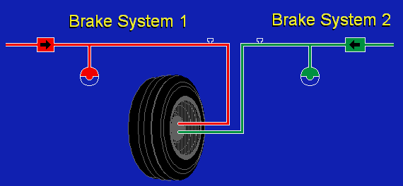
* The hydraulic systems are synchronized so that they simultaneously apply the brakes; however, the loss of either system will not affect the stopping performance of the aircraft. If both hydraulic systems fail, each brake system is equipped with a series of accumulators. The accumulators are of sufficient capacity to provide adequate brake pressure to stop the aircraft using the anti-skid braking system.

* The auto brake system, when selected, will apply the brakes during L/Ds or rejected T/O. It is activated by movement of the spoiler handle.

* Automatic braking is initiated as a result of spoiler handle movement. Automatic braking will continue to a full stop, unless manually disarmed by the pilot.

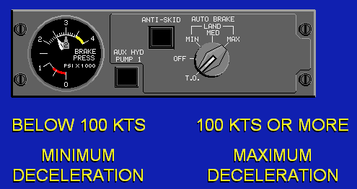

* Auto brake setting for RTO

Brake Overheat: if the temperature exceeds 800°C, stop the A/C and call emergency services also, do not set the parking brakes.

Gear Handle Will Not Move Up: There are 2 safety mechanisms to prevent movement of the L/D gear handle to the up position. They are: the main gear bogie trim system and the ground sensing system.
The L/D gear handle will not move to the "up" position until both of these systems are correct for retraction.

ELECTRONIC INSTRUMENTATION SYSTEM:

* There are 3 Display Electronic Units (DEU) that drive the 6 Display Units (DU) and provide data to the displays.
* Magenta signifies electronically generated or derived data; for example, FMS selected values.
* White is used for pilot or manually selected values, scales and associated figures.
* Cyan is used for status indications.
* Grey is used for scale shading or fixed scale labels.
* Green is used to indicate validity, such as autopilot/auto throttle dual land modes.
* Red identifies conditions which require immediate crew action or impose consistent limitations on the aircraft.
* Airspeed trend is a projection of speed to be achieved in 10 sec at the current rate of airspeed change.
* Current Vertical speed indicates thousands of feet per minute up to 9900 FPM

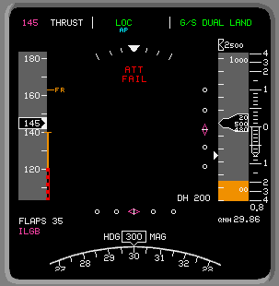
* Inertial Reference System pitch and roll failures are indicated by removal of the attitude sphere and pitch scale markings; a red "ATT FAIL" message is displayed.

* If AUX DEU failed, amber “X” over the engine 3 oil qty. is the only indication.

* 1 of the 3 DEU may be INOP for both CATII & CATIII approaches.

*

Level 3 alert: indicates an emergency operational condition requiring immediate crew action.

Level 2 alerts: indicate an abnormal operational system condition requiring immediate crew awareness and subsequent crew action.
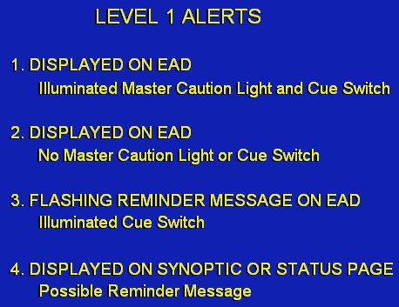
Level 1 Alert:
1. These alerts indicate an abnormal condition which requires awareness and some type of crew action.
2. These alerts require continued crew awareness and usually indicate an abnormal switch position.
3. These alerts are advisory and do not require crew action. If another change occurs in any system, the appropriate reminder message will begin flashing to alert the crew of a new change in system operation.
4. The least significant level 1 alert has no "Master Caution" light, no flashing reminder message, and no steady reminder message. It only appears on the status page; these alerts must be written into the logbook.

Level 0 alerts: when a level 0 alert is displayed, the associated cue light and the "Master Caution" lights are not illuminated. A level 0 alert is only displayed on the EAD.

Consequences:
These consequence messages provide the flight crew with necessary information for safe flight. Consequence statements should be integrated with checklist procedures to achieve maximum system recovery.

Inhibits:
During T/O, alerts are inhibited at different points during the T/O roll, based on their importance to the safety of flight.
Level 1 and 2 alerts are inhibited at throttle advance, 80 knots, or V1 - 20.
Level 3 alerts are inhibited at V1 the alerts remain inhibited to 400 feet or 1000 feet depending on the importance of timely flight crew awareness.
Alerts inhibited to 400 feet will be displayed after 25 seconds if the aircraft has not reached 400 feet.
Alerts inhibited to 1000 feet will be displayed after 120 seconds if the aircraft has not reached 1000 feet.
During L/D, Level 1 and 2 alerts are inhibited at 1000 feet or 100 feet based on their importance to the safety of flight; Level 3 alerts are not inhibited. The alerts remain inhibited until 80 knots on the L/D rollout.
Level 1 and 2 alerts inhibited at 1000 feet will be displayed after 120 seconds if an L/D and rollout to 80 knots is not completed.
Level 1 and 2 alerts inhibited at 100 feet will be displayed after 25 seconds if an L/D and rollout to 80 knots is not completed.

* The curved trend vector is displayed when the aircraft is in a turn and consists of 3 green arcs extending from the nose of the aircraft. The 30 second arc is displayed for all mileage ranges; the 60 second arc is displayed for ranges of 20 miles or more; and the 90 second arc is displayed for ranges of 40 miles or more.

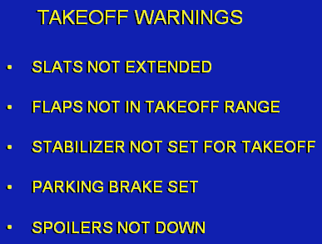
* When all essential items have been accomplished, an empty GREEN BOX is displayed.
* When the aircraft accelerates through 80 knots, the green box is no longer displayed; when any T/O essential item is displayed and the number 1 or 2 throttle is advanced for T/O, the Central Aural Warning System sounds a warning tone and a voice message for the applicable condition; at the same time, the essential item and box turn RED.

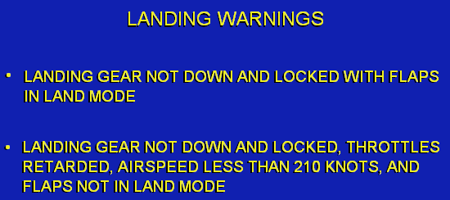

* When all 3 essential L/D items are configured for L/D, a green box is displayed at 1200 feet above ground level

Ground Proximity Warning System:
* The GPWS provides warnings for unsafe terrain clearance based on radio altitude, aircraft configuration and airspeed.
* When an unsafe condition is detected with the gear up, airspeed above 190 knots, and aircraft altitude of 500 feet or more the red flashing "Ground Proximity" warning message is displayed on the PFD "Too Low Terrain"
* When an unsafe terrain clearance is detected with the gear up, airspeed less than 190 knots, and aircraft altitude below 500 feet or airspeed less than 159 knots with altitude less than 245 feet, the voice message changes. "Too Low Gear"
*when an unsafe terrain clearance condition is detected with the gear down and flaps not in L/D configuration the red flashing "ground proximity" warning message is displayed "Too Low Flaps"
* The GPWS provides warnings for unsafe terrain clearance during T/O based on a minimum radio altitude.
* When the altitude decreases below a value stored in the radio altimeter, the red flashing "ground proximity" warning message is displayed "Too Low Terrain"
* The GPWS provides a warning when a descent below glide slope is detected.
* During an ILS approach, when a descent below glide slope is detected, the amber flashing "Below Glide Slope" annunciation is displayed on the glare shield "Glide Slope"
* The warning can be cancelled by pushing the "below glide slope" switch.
* A wind shear condition or ditching situation will also inhibit this message.

FMS/TCAS/WAGS

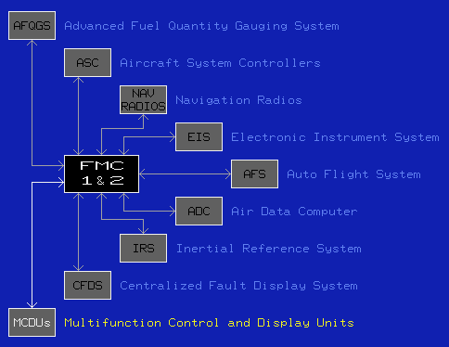

“NO FMS SPD/PROF” displayed on the A/C STATUS page when FMS is operating in a limited mode (Single FMC); all functions involving active performance and vertical guidance are inoperative (FMC speed, vertical profile, fuel computation, F-PLAN predictions). If one FMC initiates a NO FMS SPD/PROF message, the other FMC will revert to the same limited condition. This condition can be identified by “NO FMS SPD/PROF message on the A/C STATUS page, ATS OFF remains amber after engine start, T/O green band removed from stabilizer position display & thrust limit value will become dashed.

* An * (asterisk) indicates that the adjacent line select key must be pushed to activate the associated function.
A Triangle displayed adjacent to a waypoint identifier indicates the aircraft must over-fly that waypoint.
Right or left arrow indicates the direction of turn at the waypoint.
A plus or minus sign, displayed adjacent to an altitude in large font, indicates a requirement to be at or above, or at or below, the displayed altitude.

* The performance factor is a percentage performance deviation of the airframe/engine combination from nominal. A + factor is a performance decrease.

* "RNP" represents the required aircraft position for operation in a defined airspace. "ANP" is an estimate of the FMC computed aircraft position in a defined airspace. When "ANP" is greater than "RNP", "Unable RNP" is simultaneously displayed on the EAD and the ND.

* Ballast fuel, when carried, is included in the zero fuel weight and is taken from the "FUEL INIT" page.
Usable fuel onboard does not include ballast fuel.

* When an alternate is selected, this entry is computed by the FMS and may not be edited. The same rules apply to the fuel and time for holding at the alternate. Extra fuel and time for holding are computed by the FMS using available block fuel, fuel consumption rates, and computed reserves.

* The dump time on line 2R is based on dumping approximately 2260 kilograms per minute and is calculated using the "dump to gross weight" value.
* Prior to T/O, all times are estimated time en-route, ETE. After T/O the display changes to estimated time overhead, ETO.
* If a Place and Distance is used, the place must be a waypoint already in the flight plan.
* When there is an engine-out SID (EOSID) stored in the database for the selected runway, it is automatically displayed.
* The "V_{CL}" is a function of gross weight and is the FMS default speed to 10,000 feet.
* After the flap, T/O gross weight, T/O center of gravity, slope/wind and outside air temperature data fields have been filled, the FMS computes V₁, V_{R}, V₂ and V_{FR} speeds and displays them in small font

* When a de-rated thrust setting is selected, the FLEX field is removed.

* When a VOR identifier or frequency and course is entered, the "VOR ARM" prompt is displayed; pushing the line select key adjacent to the prompt arms the FMS for the VOR mode and changes the display to "VOR ARMED" in large font. When the VOR mode conditions are satisfied and the aircraft is below 18,000 feet, the prompt changes to "VOR TRACK" in large font.

* The "ECON" speed is the most economical for time and fuel, based on the cost index. This is also the default speed mode above 10,000 feet.

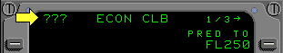
* When a conflict exists between the FCP altitude and the FMS altitude, and the aircraft is between the 2, ??? marks are displayed on the title line.

* The armed G/A thrust limit are based on the thrust limit used for T/O.

* Pushing the line select key adjacent to the "with abeam points" prompt initiates the direct-to maneuver and inserts up to 40 abeam points along the new course.
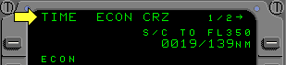
* When the last step climb has been completed, or the aircraft is within 200 Nautical Miles of the top of descent, the label on line 1 right changes to "To Top of Descent" and the "Time" and "Distance" data changes to the prediction for the top of descent.

* The flight plan has a time constraint at a waypoint, "TIME" is displayed and the ECON speed is adjusted as necessary to meet the constraint.

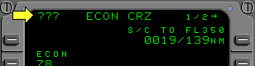
* If there is an altitude conflict between the FMS cruise altitude and the FCP selected altitude, and the aircraft is between the 2 altitudes, ??? marks are displayed on the title line.

* Fix page provides bearing and distance information from a fix to the aircraft or any point along the flight plan route. The fix may be a Place, Bearing, Distance (PBD), Latitude & Longitude or a VOR.

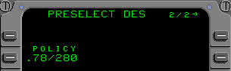
* The "Policy" mode may be entered by the flight crew selecting a calibrated airspeed which meets a specific airline descent policy; and pushing the adjacent line select key; the entry can only be made during preflight initialization.

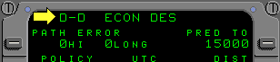
* If the aircraft is in a Drift-Down following an engine failure, "D-D" is displayed; and speeds and predictions are adjusted accordingly.

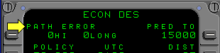
* When the FMS computed descent path is deviated

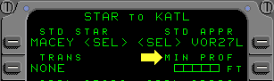

* When a non-precision approach has been selected, a minimum profile altitude must be used

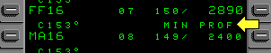

Minimum profile is displayed

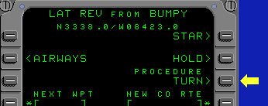
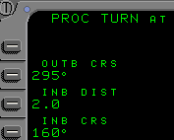

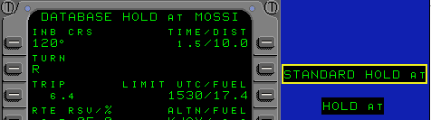
* "Standard Hold At" is the page title when the database does not contain holding parameters for the specific fix and the FMS is displaying default values based on standard ICAO or FAA procedures. When the flight crew modifies or enters the holding parameters, the page title is "Hold At".

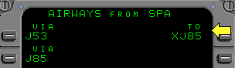
* When the intersection is not a database waypoint, the second airway identifier is displayed with an "X", to indicate the intersection has been computed by the FMS.

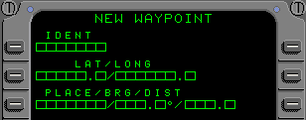

* A waypoint may be entered as a longitude and latitude, place/bearing/distance, or a runway

* The database contains 40 flight crew defined waypoints, the first waypoint not used in the flight plan is deleted and the new waypoint is entered; when all defined waypoints are used in the flight plan, new waypoints may not be entered.
* All flight crew defined waypoints will be automatically deleted when the FMS is de-powered.
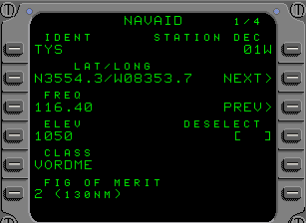
* Page 1 is the NAVAID tuned for use by the Radio Distance Magnetic Indicator (RDMI).
* Pages 2 and 3 display NAVAIDs tuned and in use by the FMS for position computation.
* Page 4 displays the "ILS/DME" NAVAID being tuned.

* Figure of Merit: which is a number used to indicate the maximum allowable distance the NAVAID can be tuned.
0 equals 40 Nautical Miles
1 equal 70 Nautical Miles
2 equal 130 Nautical Miles
3 equal 250 Nautical Miles.

* Declination which is the magnetic variation at the station location.

* The "Duplicate Names" page. It is displayed automatically when the flight crew enters a non-unique waypoint, airport runway or NAVAID identifier into a MCDU page.
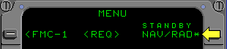
* During normal operations, the "standby NAV RADIO" prompt is displayed continuously and standby operation can be accessed at any time.

* Standby operation supplies the flight crew with a limited amount of information to complete the current flight. During standby operation, only five mode keys are operational. They are:
"Menu", "NAV Radio", "Progress", "Flight Plan", and "Direct Intercept" Keys.
* The "Closest Airports" page displays 4 airports nearest the aircraft's present position. Only airports within 4000 nautical miles are displayed.

* Maximum engine-out altitude is displayed based on 2 engines operating at Maximum Continuous Thrust.

TCAS:

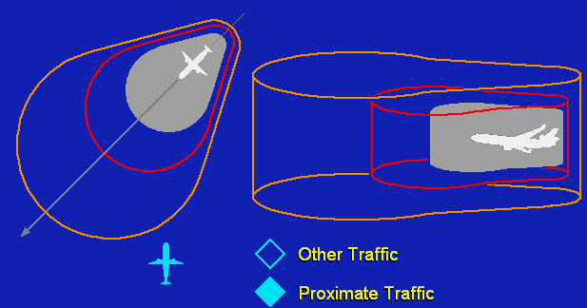
* TCAS advisories are time-based. Closure speed determines the distance at which advisories are issued.
* Traffic Advisories (TA) are issued by TCAS when aircraft intrude into the caution area.

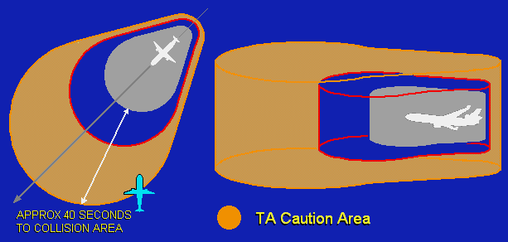

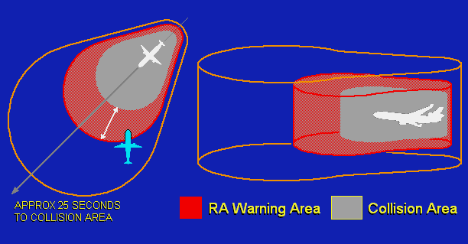
* Resolution Advisory (RA) is issued when aircraft penetrate the TCAS computed warning area.

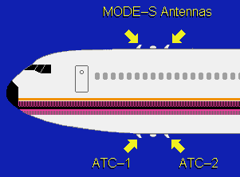

* Aircraft components required for TCAS 2 operation consist of:

The ATC-1 and ATC-2 mode "S" antennas

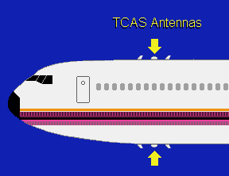

* The upper and lower TCAS directional antennas

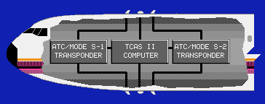

The ATC mode "S" transponders and the TCAS II computer

* TCAS will automatically revert to “TA” and only traffic alerts will be issued when below 1000 feet radio altitude. In addition, RA is inhibited when the aircraft is below 1100 feet radio altitude during T/O below 900 feet radio altitude during L/D and when a wind shear or ground proximity warning is activated.

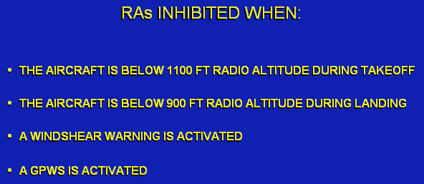
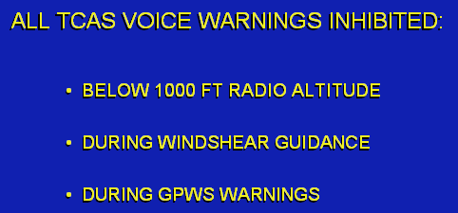


* "Proximate" Traffic displays are shown when the relative altitude of displayed Traffic is less than 1200 feet vertically and within 6 NM.


* "TA" Traffic is visually displayed and the aural "Traffic", "Traffic" advisory will sound when intruder aircraft enters the caution range.

* When TCAS is unable to track the bearing of an aircraft intruding into the caution range, this "TA" indication will be issued.
* When the Traffic mode is not engaged "Proximate" and "Other" Traffic are displayed only when a "TA" or "RA" condition exists. This "part time" mode helps to reduce non-essential clutter on the ND.

* TCAS Traffic displays are available when operating in the map, VOR, and approach modes.

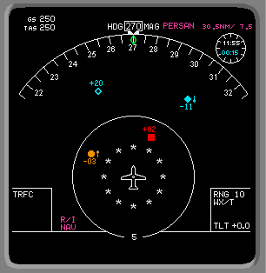
* Flight path, weather radar, bearing pointers, waypoint and airport symbols are removed and dedicated TCAS information is provided on the ND.
Additionally, range is automatically reduced to 10NM. A 5 nautical mile solid range ring and a 2 NM ring portrayed as clock positions are also displayed. The data tag, symbols, and colors identify and prioritize the intruder aircraft.

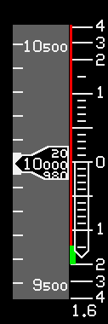

* When a "RA" is displayed on the ND, a simultaneous vertical speed advisory is displayed on the PFD.

* When an "RA" is issued color-coded indications are displayed as "Prohibited Areas" and if a vertical speed change is necessary, a green "fly to" target is displayed on the vertical speed indicator.

* TCAS does not use the flight director command bars to provide traffic separation during an "RA".
When "Auto Flight" is engaged and a corrective "RA" is issued; the pilot is expected to disconnect the autopilot, auto throttle and "hand-fly" to the TCAS commanded vertical speed band until clear of conflict. The command bars will be removed from view when the "autopilot disconnect" switch is pushed. When the aircraft is being flown manually and a corrective "RA" is issued the "autopilot disconnect" switch is pushed to remove the command bars. When the “RA” no longer exists, the command bars will re-appear and provide guidance to attain the aircraft profile that existed prior to the “RA”.

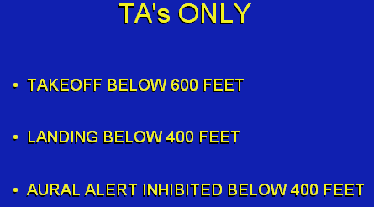
* TCAS displays only TA’s during T/O below 600 feet and L/D below 400 feet.
The “TA” aural warning is inhibited below 400 feet.
When an intruder is within 40 seconds of the collision area, the visual "TA" alert is displayed and the aural advisory sounds.
RA are indicated when intruder Traffic is within 25 seconds of collision area.

* Corrective RAs indicate flight crew action is required to avoid a collision. To respond to corrective RAs, the procedure is to disconnect the autopilot; within 5 seconds, manually fly the aircraft to attain the vertical speed displayed in green on the vertical speed indicator and avoid using vertical speeds within the areas displayed in red.

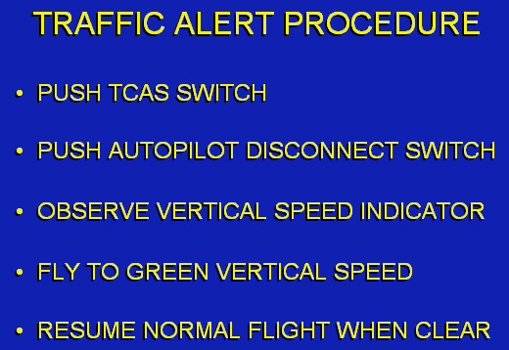

WIND SHEAR

* The Wind Shear Alerting And Guidance System (WAGS) provides detection, alerting and guidance through wind shear conditions from 80 knots on T/O roll to 1500 feet above ground; and during approaches from 1500 feet to 50 feet above ground. The WAGS is part of the Auto Flight System and receives information from the Central Air Data Computer (CADC), Inertial Reference System (IRS), Flight Management System (FMS), and other AFS components.

* Wind shear calculations are performed by the FCC. Flight director and autopilot functions are provided through the Auto Flight System. The Auto Throttle System is also activated to aid in wind shear escape.

* Wind shear conditions are classified as increasing performance (headwind shear) or decreasing performance (tailwind shear).

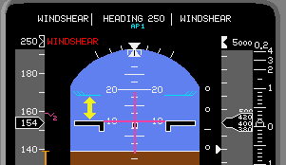

* The PLI displays the Angle Of Attack at which stick shaker will occur.
* The difference between present Angle Of Attack and the PLI indicates the margin of energy remaining to fly through the wind shear.

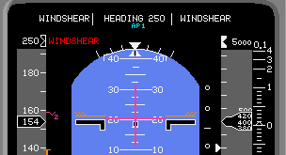
* Wind shear guidance attempts to build a reserve of energy by commanding a slight climb if possible until a safe speed is achieved. If wind shear guidance can not build an energy margin, it will prevent altitude loss by commanding pitch attitudes up to the stick shaker angle of attack until out of wind shear conditions. Wind shear guidance will not command an angle of attack which will cause a stall; it will allow a slight altitude loss at stick shaker attitude to prevent a stall.

* During a Flex T/O the Auto Throttle System unclamps, sets maximum T/O thrust, and then re-clamps.
* When the Auto Throttle System is available, but not engaged, during the T/O roll and wind shear is detected the Auto Throttle System automatically engages to provide maximum T/O thrust.
* When wind shear is detected prior to V1 and the T/O is aborted, all wind shear functions are cancelled when the throttles are retarded, except for FMA indications which remain until rollout speed is less than 30 knots.

* When a decreasing performance wind shear is detected after lift-off, the flight director command bars display the best energy conserving flight path guidance through the wind shear.
WAGS provides flight director/autopilot commands to maintain a 1 degree positive flight path angle to obtain a safe speed of V2 + 30 knots, if possible; then climbs at this speed. The aircraft is commanded to roll out of any turn and maintain wings level until wind shear is no longer detected.
* When a wind shear is encountered below 450 feet above the ground; the system commands pitch attitudes to the stick shaker angle of attack, if necessary, to prevent altitude loss. Loss of altitude occurs only as necessary to prevent a stall.

* When a wind shear is encountered at an altitude above 450 feet above ground; the system allows a zero or even slightly decreasing flight path angle to obtain the V2 + 30 knot energy target. When V2 + 30 knots are obtained, wind shear guidance commands a climb to maintain V2 + 30 knots.
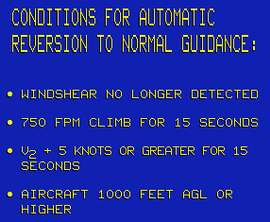
* Selection of another pitch mode by the flight crew will manually terminate wind shear pitch guidance. Selection of another roll mode will manually terminate wind shear roll guidance. If a wind shear is still detected after manual termination, pushing the "G/A" button re-engages wind shear guidance.

* During approach, wind shear detection is available from 1500 feet to 50 feet above ground. Wind shear guidance during approach with slats or flaps extended is available only after pushing the "G/A" button; or when the throttles advance to 95% of G/A thrust, either manually or by the auto throttle system.

* When a wind shear is detected on approach; the Auto Throttle System attempts to obtain a minimum speed of "V" minimum + 20 knots by advancing thrust to G/A limit if necessary. This target speed is displayed in the FMA speed window and the solid speed bug moves to the wind shear target speed. When the auto throttle system is not engaged, it automatically engages when the "G/A" button is pushed or when the crew advances the throttles to 95% of G/A thrust. Either action will initiate a G/A with wind shear guidance.

* During G/A, for a decreasing performance wind shear, autopilot/flight director guidance rolls "wings level"; the FMA roll control window displays the new "wings level" heading after flashing 5 times, and bank angle is limited to 5 degrees. "Wind Shear" flashes 5 times in the speed and altitude windows, and pitch guidance attempts to obtain "V minimum + 20 knots”, then climb at that speed.
For an increasing performance wind shear, roll mode does not change but guidance attempts to hold "V minimum + 20 knots” and climb at that speed.

* When guidance is provided; the Auto Throttle System advances throttles to maximum G/A thrust and clamps, permitting power changes by the crew without interference.

* Wind shear pitch guidance above 450 feet AGL allows a slight descent to obtain the desired minimum speed, and then provides guidance to climb at that speed.

* Wind shear pitch guidance below 450 feet AGL attempts to maintain a slight climb to prevent further altitude loss but allow speed to increase.
* In extreme wind shear conditions when a climb is not possible, wind shear guidance commands attitudes up to the stick shaker angle of attack to prevent altitude loss; altitude loss is permitted only when necessary to prevent a stall.

* When wind shear guidance sustains a climb rate of 750 feet per minute and a speed of Vref - 5 or greater for 15 seconds, and the aircraft is above 1000 feet

* Wind shear guidance is terminated and normal guidance occurs automatically; selection of another pitch mode by the flight crew will manually terminate wind shear pitch guidance. Selection of another roll mode will manually terminate wind shear roll guidance. If a wind shear is still detected after manual termination, pushing the "G/A" button re-engages wind shear guidance.

LMC:

POWER TO ILLUMINATE THE EMERGENCY LIGHTING SYSTEM IS PROVIDED SEQUENTIALLY IN THE FOLLOWING PRIORITY:
RIGHT EMERGENCY AC BUS . . .
LEFT EMERGENCY DC BUS . . .
EMERGENCY LIGHTING BATTERY.

